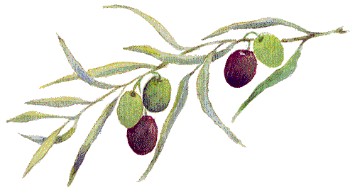

**Did you know?**

**Health Benefits**

**Olive Oil**



Olive oil has gained popularity for its many health benefits. It is great to use when cooking or baking in place of butter or vegetable oil.

Popular olive oil types are:

*Extra Virgin Olive Oil:*

Drizzle on salads or meat at the end of cooking.

*Virgin Olive Oil:*

Place a little oil in the bottom of a pan before sautéing vegetables.

*Olive Oil:*

Use instead of butter in a recipe to cut the amount of fat and cholesterol.



* Olive branches have been a symbol of peace since the olden times.
* The oldest olive tree on record was 2,000 years old!
* Christopher Columbus introduced olive oil to America.
* Olive Oyl, the character in the Popeye comic strips, was named after olive oil.

For Fun:

If olive oil is made from olives, what is baby oil made from…?







* The FDA claims two tablespoons of olive oil a day may reduce the risk of heart disease due to the monounsaturated fat.
* Olive oil contains antioxidants that may reduce the effects of arthritis and memory loss.
* Olive oil may produce similar effects to ibuprofen.

Prepared by Stacie Leahy

UW-Stout Intern, 2013