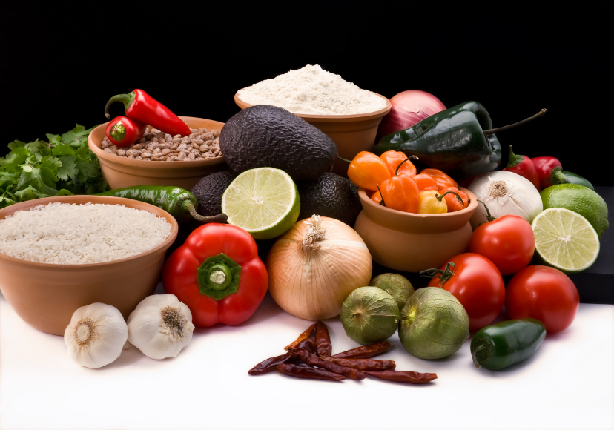
Recipe for: Extra Virgin Olive Oil Bread Dip
¼ tsp oregano
¼ tsp basil1 pinch red pepper flakes
¼ tsp rosemary2 tsp minced garlic
¼ tsp salt ¼ cup extra virgin olive oil
(Feel free to use any combination of spices you would like to equal one teaspoon)

In a small bowl, mix together the dry spices. Add garlic, stirring to moisten the herbs. Transfer to a small bowl. Pour olive oil over the mixture. Serve with fresh bread. This dip can also be drizzled over pasta, cooked meat or vegetables.
*Note: Fresh or dry herbs may be used for this recipe. If you decide to use fresh herbs in place of the dry, multiply the amount by three. For example, 1 tsp of dried oregano would equal 1 T of fresh oregano (there are 3 tsp in one T)
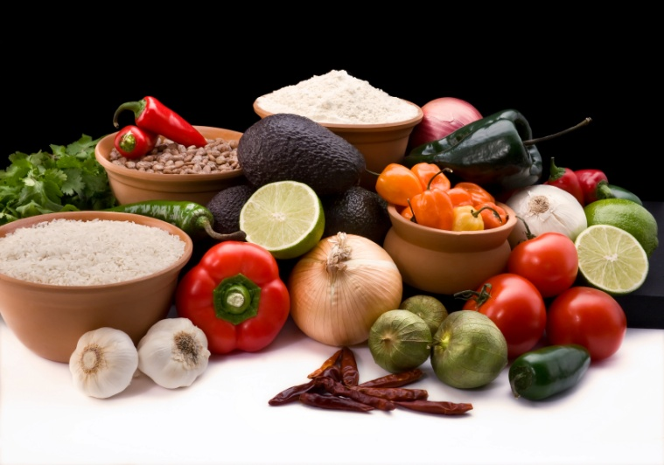


Recipe for: Baked Sweet Potato Fries

2-4 large Sweet Potatoes scrubbed clean, skin on, cut into 1/2 inch fries
2 T of olive oil (enough to lightly coat the potatoes)

Season to taste:
Paprika
Garlic Salt
Pepper
Thyme or any spice you like including: Rosemary, Smoked Paprika, Oregano, Curry Powder, Chili Powder, Cinnamon, Nutmeg, Cardamom, Ground Ginger, Allspice, Cayenne, etc.

Preheat oven to 400 degrees F. Line a baking sheet with parchment paper. Toss sweet potatoes with olive oil and chosen seasonings. Bake in oven for 30-40 minutes. Toss every 10 minutes to assure that all sides cook evenly. Adjust baking time according to how crispy you want your "fries."

