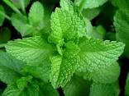
Mint is a wonderful aromatic herb. Mint can be incorporated into any dish and has great digestive abilities.

Health Benefits:
- Excellent source of Vitamin C
- Excellent source of antioxidants
- Mint is a natural stimulant
Fresh mint is a perennial! This means if you plant one now, it will come back next year and the following and the year after that. But be careful, some gardeners consider mint invasive. Consider planting mint in a pot to control it.

It is easiest to start a new mint plant from a healthy mint plant runner.

Mint to be….
Mint gets its tell tale enticing aroma from menthol, an essential oil in its leaves
Adding mint to your dishes is a great way to add natural flavor
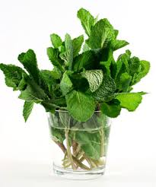
Mint is a good companion plant – naturally repelling pesky insects
Shown to aid in digestion and improve brain health
Packed with vitamin C and loaded with beneficial antioxidants
Available year-round across the country
70% of mint is grown in the US

Mint is a natural stimulant, and the smell alone can be enough to charge your batteries and get your brain functioning on a high level again. If you are feeling sluggish, or simply exhausted, mint and its derivative essential oils can help!
Enjoy some mint…
…add to cold water or hot tea
…add to fresh fruit
…toss into salads and salsa
…add to baked chicken
…add to chocolate chip cookies
…freeze mint for later use
Grow some potted mint!
Because of its health benefits and flavor, mint adds vibrant color to any dish. Even better, you can easily grow it at home to have available year round in your house.

