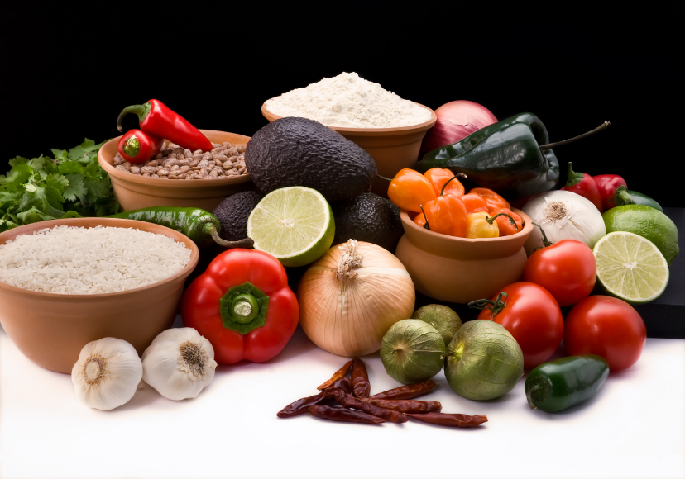
Recipe for: Refreshing Fresh Fruit with Mint

1-2 lbs variety fresh fruit

Sauce:
½ cup frozen limeade concentrate
¼ cup honey
2 T poppy seeds
Finely chopped mint

Cut up your choice of variety fresh fruit. Mix dressing together and pour over fruit. Refrigerate for 1 hour to set.
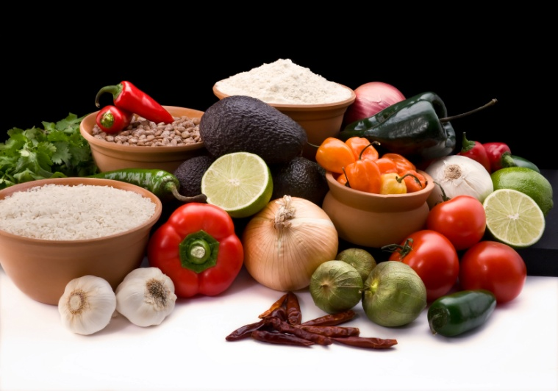

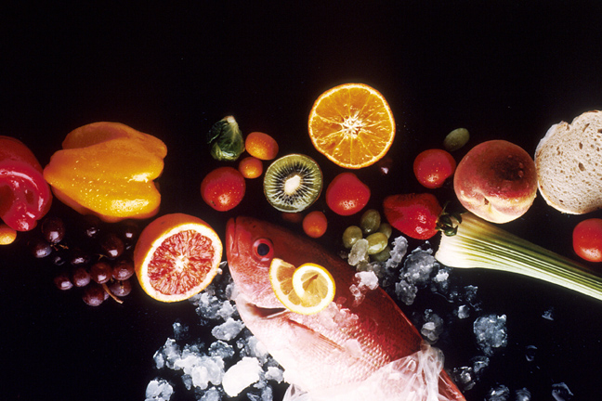
Recipe for: Super Shamrock Smoothie

2 frozen bananas
2 cups kale
1/2 T cocoa powder, optional
1 tsp chia seeds or flaxseed, optional
2 T chopped fresh mint
2 cups coconut milk

Add all ingredients to a blender. Blend until smooth. Serve cold.
Recipe for: Fresh Mint & Lemongrass Tea

1 large handful fresh mint leaves, ripped
1 stalk lemongrass, chopped
Boiling Water

Boil water, add mint and lemongrass into the teapot and allow to steep for 5 minutes. Pour into cups and drink. Don’t throw away any tea that went cold before you drank it – stick it in the fridge and you have some tasty flavored water for later!

Recipe for: Chocolate & Fresh Mint Cookies

1 cup butter2 cups flour
1 cup brown sugar¾ cup cocoa powder
1 cup white sugar1 tsp baking soda
2 eggs½ tsp salt
1 tsp vanilla1 cup fresh mint, finely chopped
2 cups chocolate chips

Preheat oven 350. Mix sugars and butter until creamy. Add eggs and vanilla. Mix together dry ingredients and add to mixture. Add chopped mint and chocolate chips. Bake 10-12 minutes, cool on cookie rack. Makes 2 dozen.

Recipe for:

Recipe for:

