

Beneficial Bites

Maple Syrup

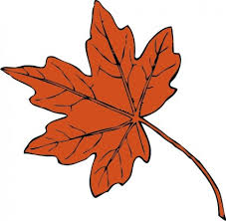

Health Benefits:

* Natural Sweetener
* Provides quick energy
* Contains minerals such as iron, calcium, manganese, zinc and potassium
* Contains antioxidant compounds

Interesting Facts:

* The sugar maple is the Wisconsin state tree
* It take 40 gallons of clear maple sap to make 1 gallon of pure maple syrup
* Maple flow usually lasts only 3-4 weeks each Spring when temperatures are right
* Quebec produces three-quarters of the world’s maple syrup; Vermont is the leading producer in the US
* 1 tablespoon has ~50 calories
* Maple Syrup can equally replace regular sugar in recipes by decreasing the liquid ingredients by half
* Maple Syrup is best used within 1 year and stored in the refrigerator



Beneficial Bites

Maple Syrup

Health Benefits:

* Natural Sweetener
* Provides quick energy
* Contains minerals such as iron, calcium, manganese, zinc and potassium
* Contains antioxidant compounds

Interesting Facts:

* The sugar maple is the Wisconsin state tree
* It take 40 gallons of clear maple sap to make 1 gallon of pure maple syrup
* Maple flow usually lasts only 3-4 weeks each Spring when temperatures are right
* Quebec produces three-quarters of the world’s maple syrup; Vermont is the leading producer in the US
* 1 tablespoon has ~50 calories
* Maple Syrup can equally replace regular sugar in recipes by decreasing the liquid ingredients by half
* Maple Syrup is best used within 1 year and stored in the refrigerator



Beneficial Bites

Maple Syrup

Health Benefits:

* Natural Sweetener
* Provides quick energy
* Contains minerals such as iron, calcium, manganese, zinc and potassium
* Contains antioxidant compounds

Interesting Facts:

* The sugar maple is the Wisconsin state tree
* It take 40 gallons of clear maple sap to make 1 gallon of pure maple syrup
* Maple flow usually lasts only 3-4 weeks each Spring when temperatures are right
* Quebec produces three-quarters of the world’s maple syrup; Vermont is the leading producer in the US
* 1 tablespoon has ~50 calories
* Maple Syrup can equally replace regular sugar in recipes by decreasing the liquid ingredients by half
* Maple Syrup is best used within 1 year and stored in the refrigerator

Check out the April menu for these “Maple Syrup” foods

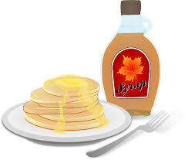

Featured Recipes:

* Maple Glazed Pork Chops
* Maple Glazed Carrots
* Maple Mashed Sweet Potatoes
* Maple and Garlic Pork Roast
* Maple Baked Beans
* White Cake with Maple Frosting

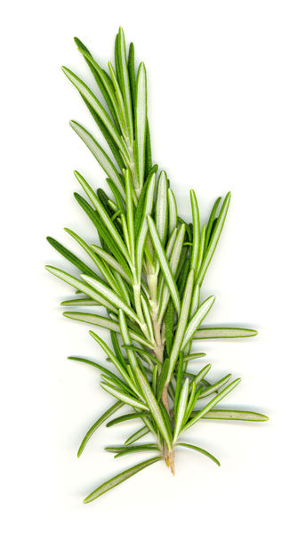

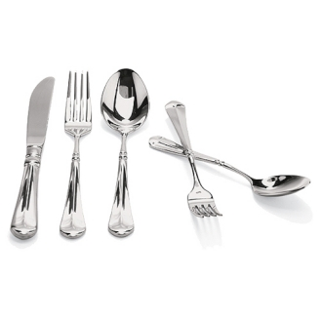

Check out the April menu for these “Maple Syrup” foods



Featured Recipes:

* Maple Glazed Pork Chops
* Maple Glazed Carrots
* Maple Mashed Sweet Potatoes
* Maple and Garlic Pork Roast
* Maple Baked Beans
* White Cake with Maple Frosting



Check out the April menu for these “Maple Syrup” foods



Featured Recipes:

* Maple Glazed Pork Chops
* Maple Glazed Carrots
* Maple Mashed Sweet Potatoes
* Maple and Garlic Pork Roast
* Maple Baked Beans
* White Cake with Maple Frosting

