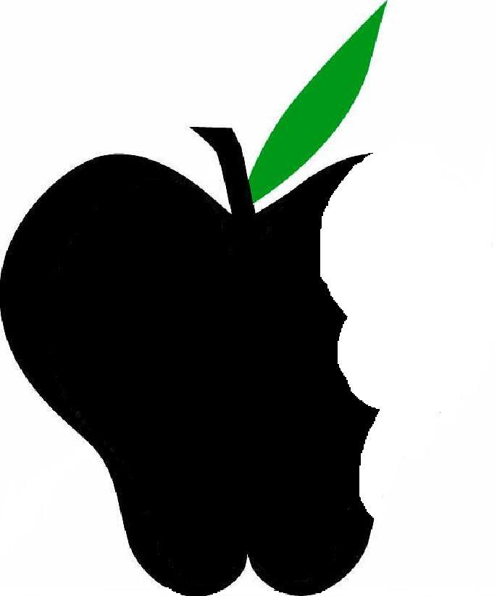
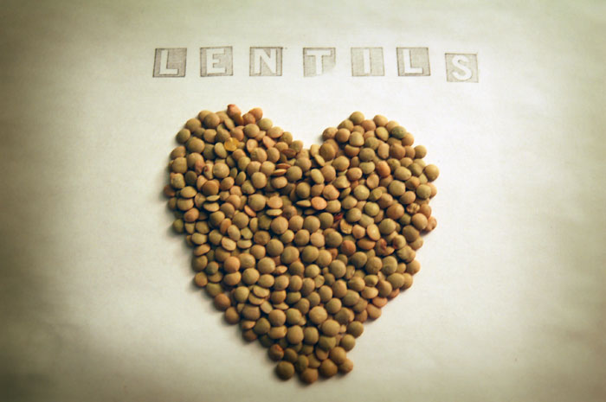
Beneficial Bites

Health Benefits

Fun Facts
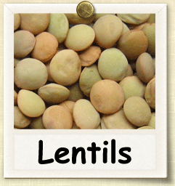
- The word lentil comes from the Latin lens, because of the lentil-shaped seeds
- Lentils have been found in the tombs of Egypt dating back to 2400 B.C.
- Although lentil is popular in West and Central Asia, people in China never really started eating a lot of lentils, because they had soybeans in China and they just kept on eating those.
- There is even a National Lentil Festival in Pullman Washington every year, started in 1989.
- In the 18th century, King Louis XV’s wife, Marie Leszczynska, made lentils fashionable among royalty and they were nicknamed “the queen’s lentils.”

- Lentils, like the other beans, are a good source of protein while low in fat. Also high in dietary fiber, which brings a lot of healthy benefits including lowering cholesterol, maintaining blood sugars, and promoting good digestion.
- Lentils are packed with folate, iron, phosphorus, and potassium. One cup of cooked lentils provides 90% of daily folic acid body needs.
- Eating lentils with meat or a rich source of vitamin C like fruits and vegetables increases the absorption of plant source iron.
Created by Li Cheng, MS, Dietetic Intern 2015

Lentils are legumes along with other types of beans. It is an annual brush plant. They grow in pods that contain either one or two lentil seeds that are lens shaped. Lentils come in three main varieties: brown, green and red.

Try Lentils in
- Salad
- Soup
- Stew
- Bakery

