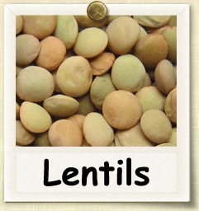

**History** Lentils are legumes along with other types of beans. It is an annual brush plant. It may have been one of the first agricultural crops

**History** Lentils are legumes along with other types of beans. It is an annual brush plant. It may have been one of the first agricultural crops



Beneficial Bites



**History** Lentils are legumes along with other types of beans. It is an annual brush plant. It may have been one of the first agricultural crops

grown more than 8,500 years ago, native in West Asia. It has been an important food in West Asia, Central Asia, North Africa and all around the Mediterranean Sea.

**Uses** Lentils work well in soups, stews and salads. They also work well as a main or side dish — boil them for 15 to 30 minutes, add seasonings, and serve over rice or mix with other vegetables. Basically there are three different colors of lentil. Brown lentils are good for soup; green lentils are best for salad; and red ones can be pureed.

**Health Benefits** Lentils, like other beans, are a good source of protein, dietary fiber, folic acid, and iron. They are low in fat and sodium.

grown more than 8,500 years ago, native in West Asia. It has been an important food in West Asia, Central Asia, North Africa and all around the Mediterranean Sea.

**Uses** Lentils work well in soups, stews and salads. They also work well as a main or side dish — boil them for 15 to 30 minutes, add seasonings, and serve over rice or mix with other vegetables. Basically there are three different colors of lentil. Brown lentils are good for soup; green lentils are best for salad; and red ones can be pureed.

**Health Benefits** Lentils, like other beans, are a good source of protein, dietary fiber, folic acid, and iron. They are low in fat and sodium.

grown more than 8,500 years ago, native in West Asia. It has been an important food in West Asia, Central Asia, North Africa and all around the Mediterranean Sea.

**Uses** Lentils work well in soups, stews and salads. They also work well as a main or side dish — boil them for 15 to 30 minutes, add seasonings, and serve over rice or mix with other vegetables. Basically there are three different colors of lentil. Brown lentils are good for soup; green lentils are best for salad; and red ones can be pureed.

**Health Benefits** Lentils, like other beans, are a good source of protein, dietary fiber, folic acid, and iron. They are low in fat and sodium.



Beneficial Bites



Beneficial Bites

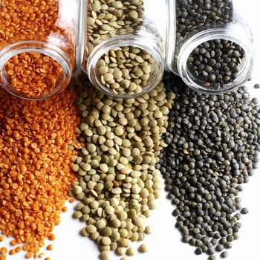

**Fun Facts**

* The word lentils comes from the Latin lens, because of the lentil-shaped seeds
* Lentils have been found in the tombs of Egypt dating back to 2400 B.C.
* There is even a National Lentil Festival in Pullman Washington every year, started in 1989.

Created by Li Cheng, MS, UW-Stout Dietetic Intern, 2015

**Fun Facts**

* The word lentils comes from the Latin lens, because of the lentil-shaped seeds
* Lentils have been found in the tombs of Egypt dating back to 2400 B.C.
* There is even a National Lentil Festival in Pullman Washington every year, started in 1989.

Created by Li Cheng, MS, UW-Stout Dietetic Intern, 2015

**Fun Facts**

* The word lentils comes from the Latin lens, because of the lentil-shaped seeds
* Lentils have been found in the tombs of Egypt dating back to 2400 B.C.
* There is even a National Lentil Festival in Pullman Washington every year, started in 1989.

Created by Li Cheng, MS, UW-Stout Dietetic Intern, 2015

**Check Out the March Menu**

**for These “Lentil” Foods**

* Curried Red Lentils
* Lentil Stew with Carrots and Potatoes
* Cold Lentil & Barley Salad

**Check Out the March Menu**

**for These “Lentil” Foods**

* Curried Red Lentils
* Lentil Stew with Carrots and Potatoes
* Cold Lentil & Barley Salad

**Check Out the March Menu**

**for These “Lentil” Foods**

* Curried Red Lentils
* Lentil Stew with Carrots and Potatoes
* Cold Lentil & Barley Salad



Beneficial Bites



Beneficial Bites



Beneficial Bites