
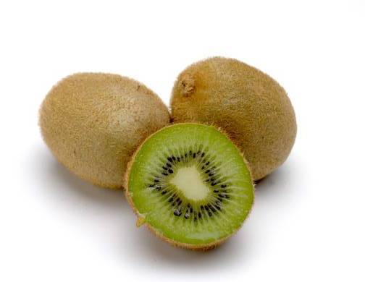

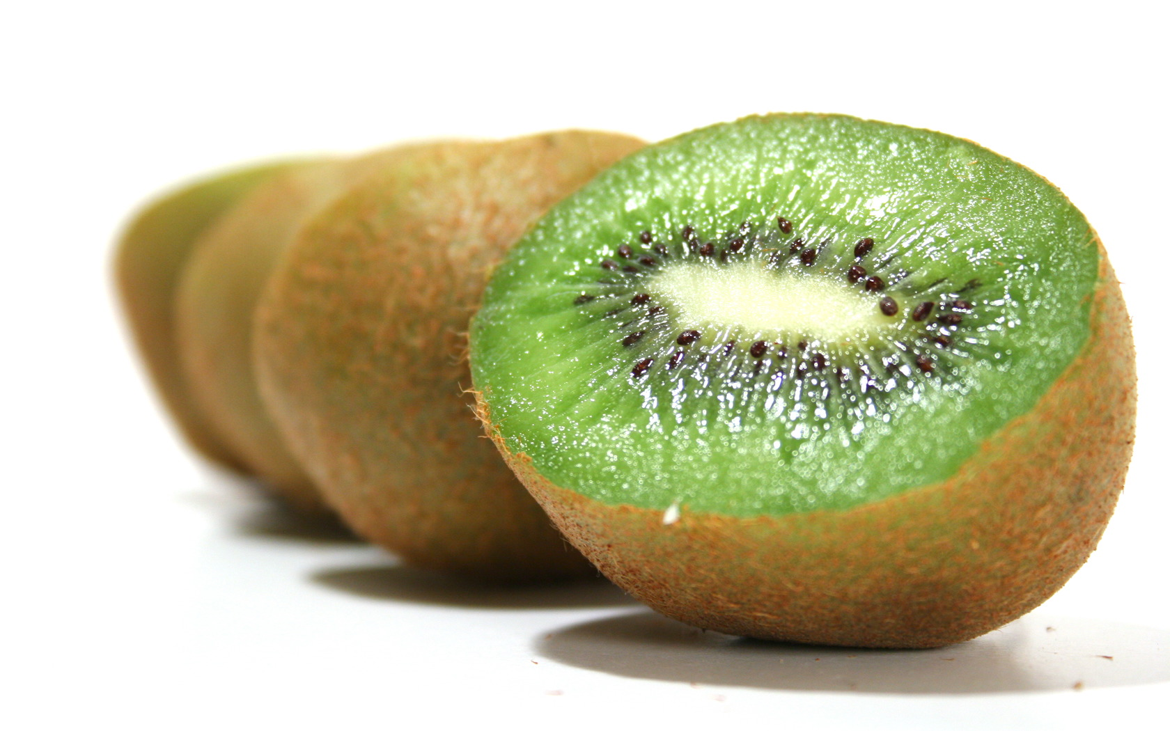
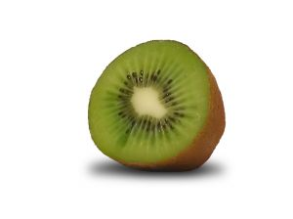


PLACE PHOTO HERE,
OTHERWISE DELETE BOX

Beneficial Bites
- In France, kiwifruit’s translation means “vegetable mouse” because of its furry covering. Doesn’t that sound tasty?

- Cats love to rub against kiwifruit plants because the trunks have a catnip-like aroma.

- Kiwifruits are also known as the Chinese Gooseberry.

Kiwifruit Connection
Quick Kiwi Tips

- Easy to slice in half, scoop out with a spoon and enjoy alone, or slice it into desserts, salads, or side dishes.
- Select kiwifruits that are unblemished and firm but not rock hard. The flesh should yield to gentle pressure.
- You can easily ripen a kiwifruit by leaving it at room temperature for a few days.
- Kiwifruit is a natural meat tenderizer. Cut in half and rub over the meat.
- For home usage, it is best to use kiwifruit within 1 week.

Joke: Why did the kiwifruit go out with the prune?
Answer: Because it couldn't get a date.
Written and created by Robyn Verschay, UW-Stout Dietetic Intern, 9/2009

- Kiwifruits are actually considered a berry.

- One kiwifruit will provide 100% of your daily recommended intake of vitamin C.

- Kiwifruits are often referred to as kiwis.
A kiwi is a small flightless bird
from New Zealand.

