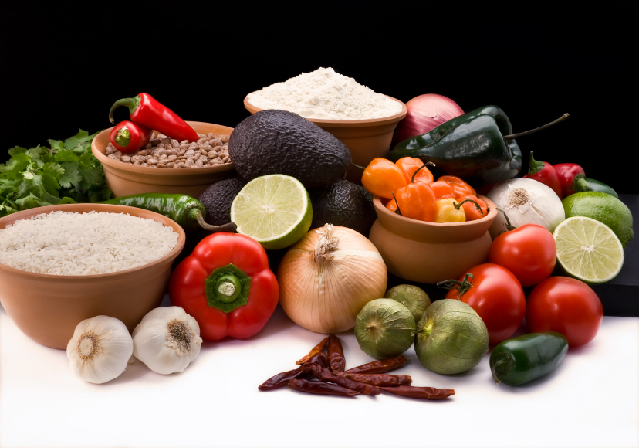
Recipe for: Pineapple Kiwi Jam

4 Kiwifruit, peeled and thinly sliced
3 cups sugar
1 – 8 oz can crushed pineapple, undrained
¼ cup lime juice
1 (3 oz) pouch liquid fruit pectin
3 drops green food coloring, optional

In a 2-qt microwave bowl, combine kiwi, sugar, pineapple and lime juice. Microwave, uncovered on high for 7-10 minutes, until mixture comes to full rolling bowl, and stirring every 2 minutes. Stir in pectin. Add food coloring if desired.
Pour into jars or freezer containers and cool to room temperature, about 1 hour. Cover and let stand overnight or until set, but not longer than 24 hours. Refrigerate or freeze. Yields 4 cups.

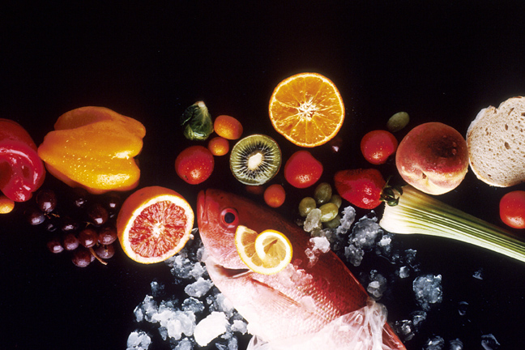
Recipe for: Kiwifruit Sorbet

2 cups unsweetened apple juice
1 tablespoon lemon or lime juice
4 medium kiwifruit, peeled
6 teaspoons sugar
½ teaspoon grated orange peel

Combine juices and kiwifruit in blender and process until smooth. Add sugar and orange peel and processed until mixed well. Pour into bowl, cover and freeze for 1-2 hours or until partially set.

Transfer to large bowl and beat on medium speed for 1-2 minutes. Return to other dish and freeze for 2-3 hours or until firm. Before serving, let stand at room temperature for 5-10 minutes or long enough to be able to spoon into serving dishes.
Makes 6 generous servings.

Recipe for: Kiwifruit Champagne Vinaigrette

2 Kiwifruit, peeled
2/3 cup Olive oil
¼ cup Champagne vinegar (can substitute with rice or white wine vinegar)
¼ cup Orange Juice
1 tablespoon fresh cilantro, chopped
1 teaspoon sugar
¼ teaspoon salt
¼ teaspoon ground pepper

Combine all ingredients in food processor or blender and process until blended. Makes 1 ½ cups dressing. Serve with mixed tossed green salad.

Recipe for: Quick & Easy Kiwifruit Sorbet

4 Kiwifruit, peeled
1 -12 oz can frozen lemonade or limeade concentrate
2 cups water

Blend all ingredients until smooth. Pour into bowl and freeze overnight.

