Kiwifruit Bingo
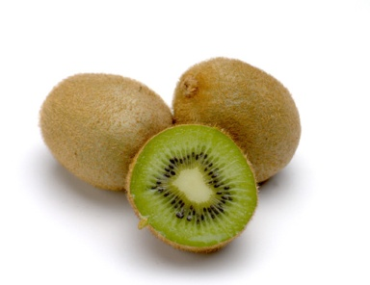
Your packet includes:
- Forty bingo cards
- Call-outs for words and phrases
- Kiwifruit pictures as optional markers
- Meal ticket
Whenever you decide to play bingo, please let the kitchen know so they can have kiwifruit on hand.

Kiwifruit samples:
Wash them like you would other fruit. Be sure to have folks try the kiwifruit with the skin-on. You can also make other items (recipes included) or have just the kiwifruit slices. If you decide to prepare something using kiwifruit, charge necessary ingredients at local store where we have an account or contact me.
Bingo prizes:
Bingo winners should receive a kiwifruit as a prize. When done playing, put all names in drawing for a free meal (ticket included).

