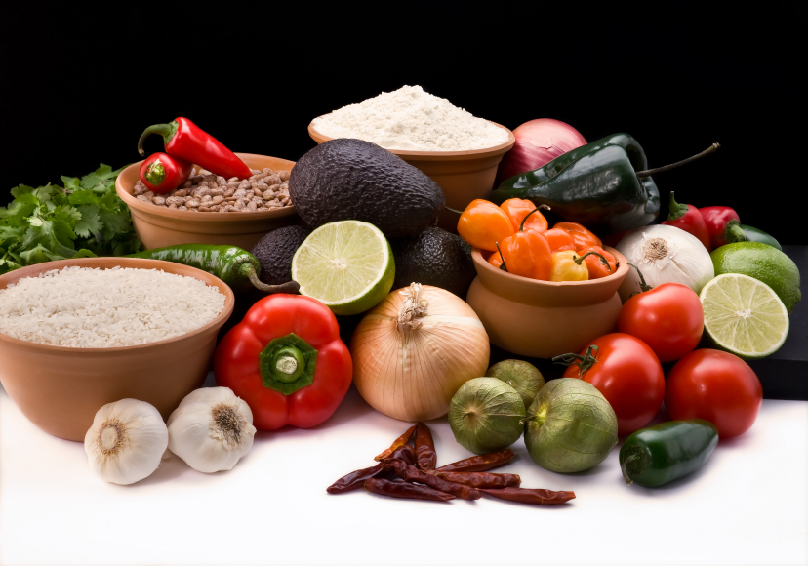
Recipe for: Maple Flavored Sweet Potatoes

6 medium sweet potatoes
½ cup maple syrup
1 T melted butter
¼ tsp cinnamon
½ cup apple cider
¼ cup sliced almonds

Cook potatoes until nearly tender; peel and slice into a baking dish. Heat maple syrup, butter, cinnamon and cider until warm (do not boil). Pour over potatoes, sprinkle with almonds. Bake 350 degrees for 45 minutes.

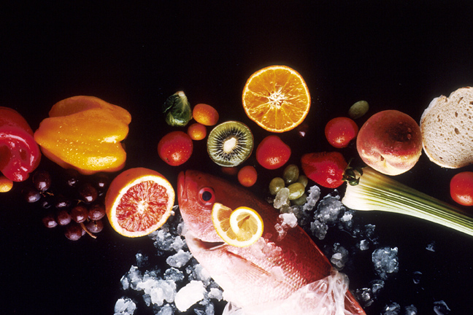
Recipe for:
1 bunch kale
4 cloves garlic
¾ cup olive oil
1 cup grated Parmesan
1 T fresh lemon juice
Salt and Pepper

Blanch garlic cloves for 2-3 minutes; remove from water with a slotted spoon. In same water, blanch 1 bunch of stemmed kale for 30 seconds; drain. Purée garlic and kale in a food processor; with motor running, gradually add the extra-virgin olive oil, grated Parmesan, and fresh lemon juice; season with kosher salt and freshly ground black pepper. Use pesto to dress cooked pasta of your choice or as a sauce for vegetables or fish or on breads.

Recipe for: Tropical Kale Slushy
2-3 kale leaves
2 cups fresh pineapple
1 peeled kiwi
¼ c loosely packed fresh mint leaves (optional)
Combine kale leaves, chopped fresh pineapple, kiwi, and fresh mint leaves in a blender. Add ice and enough water to cover; purée until smooth. Enjoy this refreshing smoothie at breakfast or anytime of the day!
Recipe for: Kale Chips

1 bunch kale
3 T olive oil
1 T soy sauce
Tear leafy parts from a bunch of kale into 2″-3″ pieces. Whisk olive oil and soy sauce in a large bowl; add kale and toss to coat. Spread out kale in an even layer on a baking sheet. Cover with another baking sheet and bake in a 300° oven until crisp, 12-15 minutes.

