

Beneficial Bites

Honey

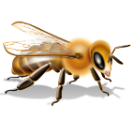

Health Benefits:

* Natural Sweetener
* Natural throat soother
* Provides quick energy
* Contains a wide array of vitamins, minerals, and amino acids
* Contains antioxidant compounds

Interesting Facts:

* There are more than 300 unique kinds of honey in the United States.
* Honey bees may travel as far as 55,000 miles and stop at two million flowers to gather enough nectar to produce a pound of honey.
* In general, lighter colored honeys are mild in flavor, and darker honeys are usually stronger in flavor.
* Nectar contains about 85-90% water, and needs to be dehydrated down to less than 18.6% water to be honey.
* It takes about two tablespoons of honey to fuel a honey bee’s flight around the world.
* North Dakota is the leading state in honey production.



Beneficial Bites

Honey

Health Benefits:

* Natural Sweetener
* Natural throat soother
* Provides quick energy
* Contains a wide array of vitamins, minerals, and amino acids
* Contains antioxidant compounds

Interesting Facts:

* There are more than 300 unique kinds of honey in the United States.
* Honey bees may travel as far as 55,000 miles and stop at two million flowers to gather enough nectar to produce a pound of honey.
* In general, lighter colored honeys are mild in flavor, and darker honeys are usually stronger in flavor.
* Nectar contains about 85-90% water, and needs to be dehydrated down to less than 18.6% water to be honey.
* It takes about two tablespoons of honey to fuel a honey bee’s flight around the world.
* North Dakota is the leading state in honey production.



Beneficial Bites

Honey

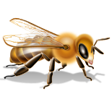

Health Benefits:

* Natural Sweetener
* Natural throat soother
* Provides quick energy
* Contains a wide array of vitamins, minerals, and amino acids
* Contains antioxidant compounds

Interesting Facts:

* There are more than 300 unique kinds of honey in the United States.
* Honey bees may travel as far as 55,000 miles and stop at two million flowers to gather enough nectar to produce a pound of honey.
* In general, lighter colored honeys are mild in flavor, and darker honeys are usually stronger in flavor.
* Nectar contains about 85-90% water, and needs to be dehydrated down to less than 18.6% water to be honey.
* It takes about two tablespoons of honey to fuel a honey bee’s flight around the world.
* North Dakota is the leading state in honey production.

Check out the January menu for these “Honey” foods

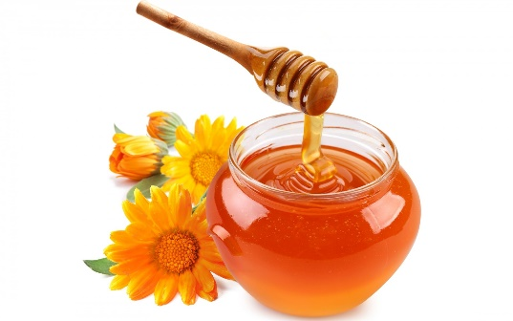

Featured Recipes:

* Honey Sunflower Bread
* Sweet Potatoes with Honey
* Honey Glazed Chicken
* Pumpkin Honey Bread
* Honey Pulled Pork Sandwiches
* Apple Honey Crisp
* Honey Oatmeal Raisin Cookies

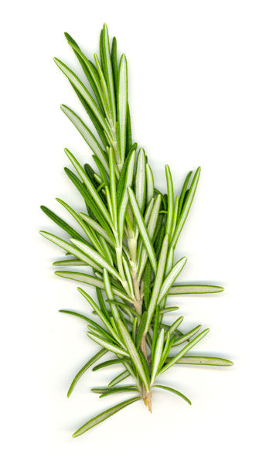



Created by Melissa Panchyshyn, MS

UW-Stout Dietetic Intern

Check out the January menu for these “Honey” foods



Featured Recipes:

* Honey Sunflower Bread
* Sweet Potatoes with Honey
* Honey Glazed Chicken
* Pumpkin Honey Bread
* Honey Pulled Pork Sandwiches
* Apple Honey Crisp
* Honey Oatmeal Raisin Cookies



Created by Melissa Panchyshyn, MS

UW-Stout Dietetic Intern

Check out the January menu for these “Honey” foods



Featured Recipes:

* Honey Sunflower Bread
* Sweet Potatoes with Honey
* Honey Glazed Chicken
* Pumpkin Honey Bread
* Honey Pulled Pork Sandwiches
* Apple Honey Crisp
* Honey Oatmeal Raisin Cookies



Created by Melissa Panchyshyn, MS

UW-Stout Dietetic Intern