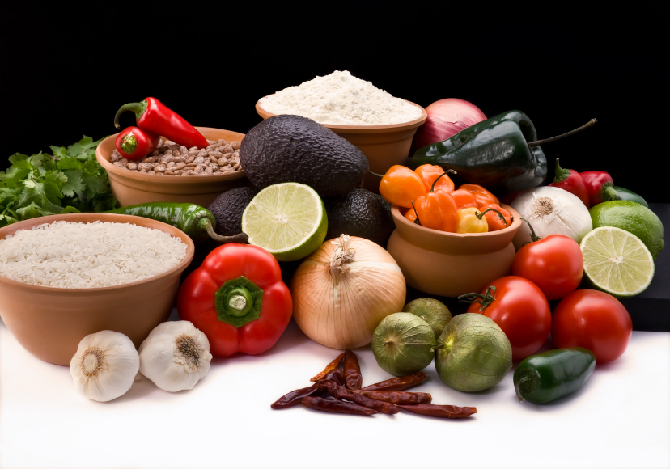
Recipe for: Cashew Snow Pea Salad
3 cups fresh snow peas, halved
2 cups chopped cauliflower
1 cup chopped celery
1/4 cup chopped green onions
1/2 cup reduced-fat sour cream
1/2 cup reduced-fat ranch salad dressing
Leaf lettuce, optional
3 bacon strips, cooked and crumbled
1/3 cup chopped cashews

In large bowl, combine peas, cauliflower, celery, and green onions. Whisk together sour cream and ranch dressing in small bowl. Pour over vegetables and toss to coat. Stir in bacon and cashews. Serve on lettuce leaf if desired.
Recipe from Taste of Home website www.tasteofhome.com

Recipe from Taste of Home website www.tasteofhome.com

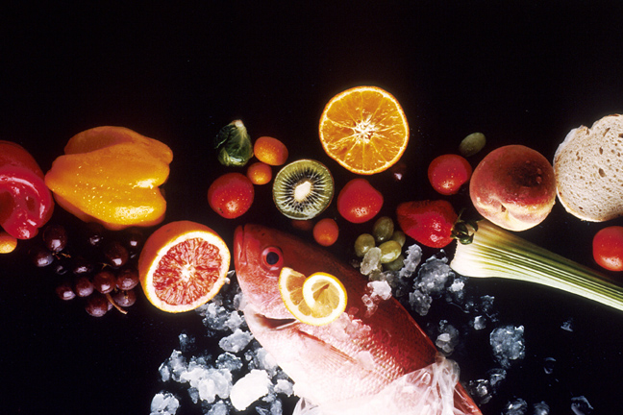
Recipe for: Asian Chicken Pasta Toss
8 ounces uncooked whole wheat thin spaghetti
2 ½ cups julienned carrots
2 ½ cups sugar snap peas
2 cups cubed cooked chicken
1 small can mandarin oranges, undrained
1/2 cup stir-fry sauce

Cook spaghetti as directed. About 2 minutes before pasta is done cooking, add carrots and peas. Drain. Add chicken, mandarin oranges and stir fry sauce. Toss to coat and serve immediately.

To reduce sodium, you can substitute up to half of the stir-fry sauce for sodium free chicken broth.

Recipe for: Apricot Citrus Glazed Vegetables
2 tablespoons apricot preserves
1 ½ tablespoons butter, melted
1/2 teaspoon grated orange peel
1/4 teaspoon lemon juice
1/8 teaspoon ground nutmeg
Dash salt and pepper
2 cups sliced carrots
1 medium zucchini sliced
3 cups sugar snap peas

Combine preserves, butter, orange peel, lemon juice, nutmeg and salt/pepper in small bowl. Set aside. Steam carrots and peas for 2-3 minutes. Add zucchini and steam another 2-3 minutes until all vegetables are tender and slightly crisp. Drizzle glaze over vegetables and toss until lightly coated. Serve immediately.

Recipe from Taste of Home website www.tasteofhome.com
Recipe for: Asian Beef with Noodles
4 ounces uncooked spaghetti, broken in half
1 ½ cups fresh sugar snap peas½ cup julienned sweet red pepper
¼ cup Catalina salad dressing½ pound beef top sirloin steak, cut into thin strips
1 tablespoons creamy peanut butter1 tablespoons soy sauce
¼ cup thinly sliced green onions¼ cup dry roasted peanuts

In a large saucepan, cook spaghetti according to package directions, adding the snap peas and pepper during the last 2 minutes of cooking; drain.

Meanwhile, in a large skillet, heat salad dressing over medium-high heat. Add beef; cook for 8-10 minutes or until meat reaches desired doneness. Add peanut butter and soy sauce; cook for 2 minutes or until thickened. Stir in the spaghetti mixture and onions; sprinkle with peanuts. Serves 2-3.

Recipe from Taste of Home website www.tasteofhome.com

