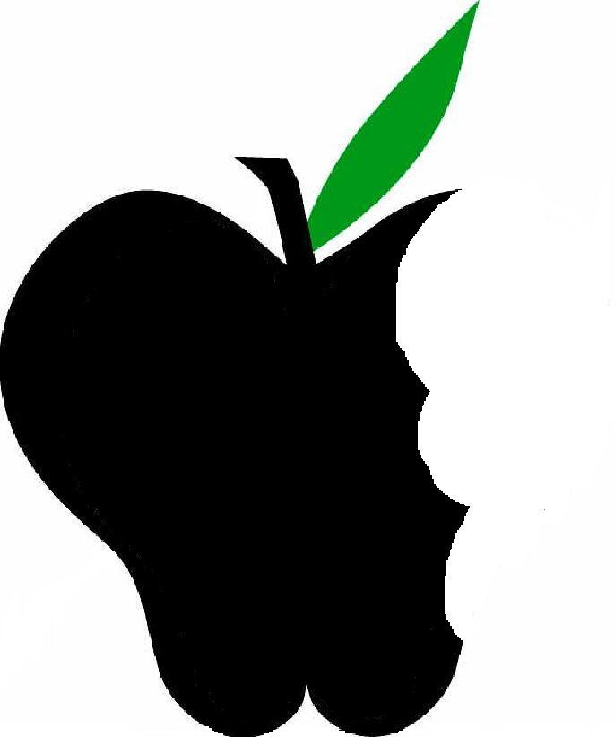

Peas have been around for a very long time. Archeologists discovered them in the Middle East many years ago. Today peas are classified as lentils and beans. These small, spherical vegetables grow inside of a pod which can be taken off before consumption. However, some pods are edible such as snap peas and snow peas. Shelling the peas is fairly easy but time consuming.

**Health benefits**

* High in fiber and protein
* Vitamins A, B6, E, and K.
* Antioxidants
  + Saponin- lower cholesterol
  + Lutein- eye health
  + Polyphenols- fight heart disease and cancer
* Omega-3fatty acids lower risk of heart disease, high cholesterol, diabetes, osteoporosis, rheumatoid arthritis.



Peas have been around for a very long time. Archeologists discovered them in the Middle East many years ago. Today peas are classified as lentils and beans. These small, spherical vegetables grow inside of a pod which can be taken off before consumption. However, some pods are edible such as snap peas and snow peas. Shelling the peas is fairly easy but time consuming.

**Health benefits**

* High in fiber and protein
* Vitamins A, B6, E, and K.
* Antioxidants
  + Saponin- lower cholesterol
  + Lutein- eye health
  + Polyphenols- fight heart disease and cancer
* Omega-3fatty acids lower risk of heart disease, high cholesterol, diabetes, osteoporosis, rheumatoid arthritis.

Peas have been around for a very long time. Archeologists discovered them in the Middle East many years ago. Today peas are classified as lentils and beans. These small, spherical vegetables grow inside of a pod which can be taken off before consumption. However, some pods are edible such as snap peas and snow peas. Shelling the peas is fairly easy but time consuming.

**Health benefits**

* High in fiber and protein
* Vitamins A, B6, E, and K.
* Antioxidants
  + Saponin- lower cholesterol
  + Lutein- eye health
  + Polyphenols- fight heart disease and cancer
* Omega-3fatty acids lower risk of heart disease, high cholesterol, diabetes, osteoporosis, rheumatoid arthritis.

**Exercise your Brain!**

**Unscramble the words**

(Hint: the other side of this paper could be a helpful for solving.)

1. iebrf _ _ _ _ _
2. lsetnil _ _ _ _ _ _ _
3. svtianmi _ _ _ _ _ _ _ _
4. prneoti _ _ _ _ _ _ _
5. dibtaees _ _ _ _ _ _ _ _
6. moeag3 _ _ _ _ _ - _
7. unteiln _ _ _ _ _ _ _
8. apsonni _ _ _ _ _ _ _



**Exercise your Brain!**

**Unscramble the words**

(Hint: the other side of this paper could be a helpful for solving.)

1. iebrf _ _ _ _ _
2. lsetnil _ _ _ _ _ _ _
3. svtianmi _ _ _ _ _ _ _ _
4. prneoti _ _ _ _ _ _ _
5. dibtaees _ _ _ _ _ _ _ _
6. moeag3 _ _ _ _ _ - _
7. unteiln _ _ _ _ _ _ _
8. apsonni _ _ _ _ _ _ _



**Exercise your Brain!**

**Unscramble the words**

(Hint: the other side of this paper could be a helpful for solving.)

1. iebrf _ _ _ _ _
2. lsetnil _ _ _ _ _ _ _
3. svtianmi _ _ _ _ _ _ _ _
4. prneoti _ _ _ _ _ _ _
5. dibtaees _ _ _ _ _ _ _ _
6. moeag3 _ _ _ _ _ - _
7. unteiln _ _ _ _ _ _ _
8. apsonni _ _ _ _ _ _ _

