
Beneficial Bites

Green Onions

Did you know...?

Health Facts

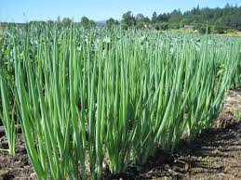
- Low in calories
- Naturally lowers blood pressure
- Contains a variety of vitamins
- Contains cancer-fighting compounds



- Green onions are simply immature common onions of any variety and are also known as “scallions”.

- Ancient Chinese medicine used green onions to induce sweating to stomp out colds.

- Green onions are a versatile veggie! Try preparing in a variety of methods and in a variety of dishes.

The Allium family
- Onions
- Garlic
- Leeks
- Shallots
- Chives
Green onions can regenerate. To do this, replant the bottom inch the green onion in damp soil or a jar of water. Place in the sun and the green onions will be ready to use in about a week.

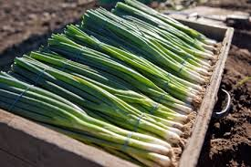

Created by Kathryn Hoff, MS, Dietetic Intern April, 2015
Beneficial Bites

