

Beneficial Bites

Green Onions

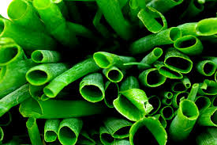Health Benefits:

* Low in calories
* Naturally lowers blood pressure
* Contains a variety of vitamins
* Contains cancer-fighting compounds

Interesting Facts:

* Green onions are simply immature common onions of any variety and are also known as “scallions”.
* Ancient Chinese medicine used green onions to induce sweating to stomp out colds.
* Green onions are a versatile veggie! Try preparing in a variety of methods and in a variety of dishes.
* Green onions can regenerate. To do this, replant the bottom inch of the green onion in damp soil or a jar of water. Place in the sun and the green onions will be ready to use in about a week.



Beneficial Bites

Green Onions

Health Benefits:

* Low in calories
* Naturally lowers blood pressure
* Contains a wide array of vitamins
* Contains cancer-fighting compounds

Interesting Facts:

* Green onions are simply immature common onions of any variety and are also known as “scallions”.
* Ancient Chinese medicine used green onions to induce sweating to stomp out colds.
* Green onions are a versatile veggie! Try preparing in a variety of methods and in a variety of dishes.
* Green onions can regenerate. To do this, replant the bottom inch of the green onion in damp soil or a jar of water. Place in the sun and the green onions will be ready to use in about a week.



Beneficial Bites

Green Onions

Health Benefits:

* Low in calories
* Naturally lower blood pressure
* Contains a wide array of vitamins
* Contains cancer-fighting compounds

Interesting Facts:

* Green onions are simply immature common onions of any variety and are also known as “scallions”.
* Ancient Chinese medicine used green onions to induce sweating to stomp out colds.

* Green onions are a versatile veggie! Try preparing in a variety of methods and in a variety of dishes.
* Green onions can regenerate. To do this, replant the bottom inch of the green onion in damp soil or a jar of water. Place in the sun and the green onions will be ready to use in about a week.

Check out the May menu for these “Green Onion” foods

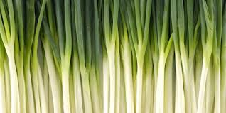

Featured Recipes:

* Broccoli cream soup with green onion
* Scallion couscous
* Potato salad with sour cream and green onion
* Chicken with green onion sauce
* Fresh green onion

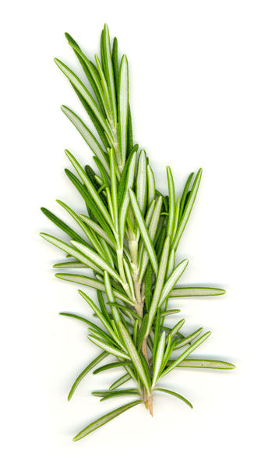



Created by Kathryn Hoff, MS

UW-Stout Dietetic Intern, April 2015

Check out the May menu for these “Green Onion” foods



Featured Recipes:

* Broccoli cream soup with green onion
* Scallion couscous
* Potato salad with sour cream and green onion
* Chicken with green onion sauce
* Fresh green onion



Created by Kathryn Hoff, MS

UW-Stout Dietetic Intern, April 2015

Check out the May menu for these “Green Onion” foods



Featured Recipes:

* Broccoli cream soup with green onion
* Scallion couscous
* Potato salad with sour cream and green onion
* Chicken with green onion sauce
* Fresh green onion



Created by Kathryn Hoff, MS

UW-Stout Dietetic Intern, April 2015