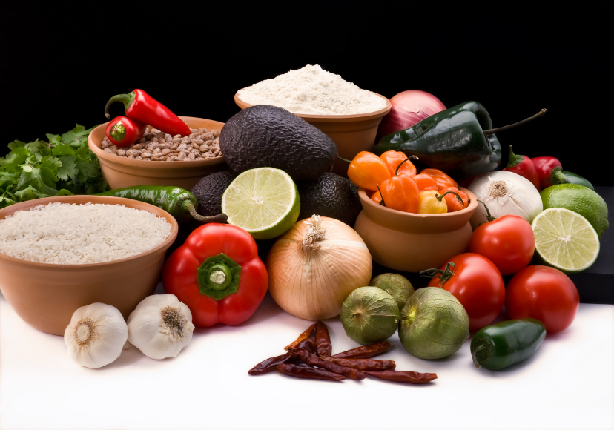
Recipe for: Poached Pears in Grape Juice
1 ½ cup 100% Grape Juice
2 cinnamon sticks
2 strips orange rind (2” x 1“)
4 pears – Bosc or Bartlet (peeled & halved leaving stem intact
In a medium saucepan bring the grape juice, cinnamon and orange rind to a boil. Place the pears upright with the stem on top into the saucepan and simmer for 15-20 minutes on medium to low heat. Make sure to keep the pears moist by spooning the juice over them as they simmer. Remove pears from the sauce, reserve and cool completely.
Simmer the remaining sauce and reduce it to about 1/3 of a cup. Remove from heat and cool. Drizzle the sauce over the pears when ready to serve and garnish with whipped cream or vanilla pudding.

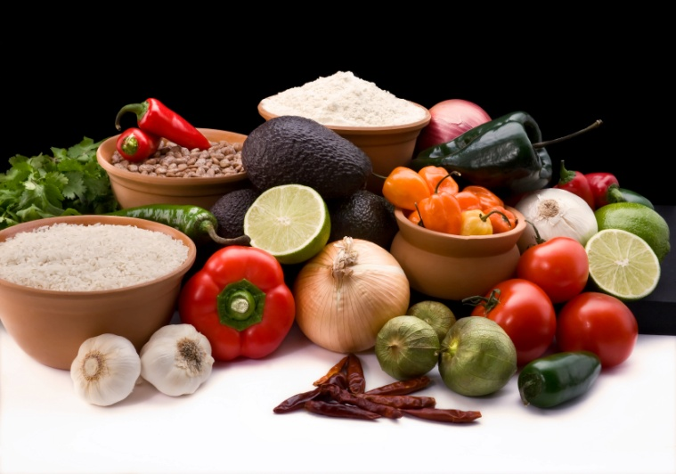

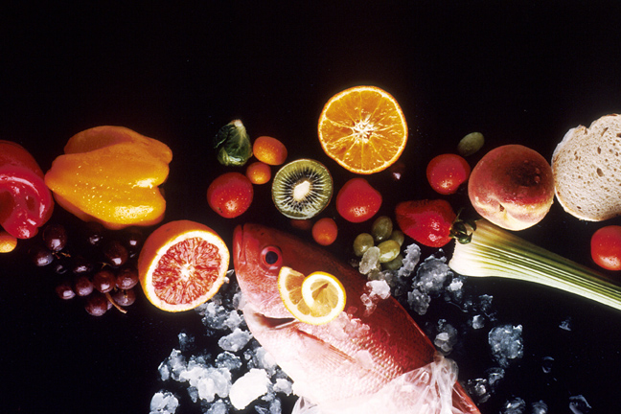
Recipe for: Speedy Barbecue Sauce
¼ cup cider vinegar
½ cup 100% Grape Juice
½ cup 100% White Grape Juice
1 cup canned tomatoes, crushed, diced or puréed
3 tbsp packed brown sugar
1 tbsp Worcestershire sauce
1 tbsp tomato paste
1 tsp hot pepper sauce
2 tbsp chopped garlic

Combine all the ingredients in a medium saucepan and bring to a boil over medium heat.
Reduce the heat and simmer for 20 minutes, stirring frequently. Remove from the heat and cool slightly before using. Store in an airtight container in the refrigerator.

Recipe for: Herbed Wild Rice Pilaf w/Grapes
2 tablespoons butter
1 small onion, finely chopped
Coarse salt and ground pepper
2 cups wild-rice blend (from two 6-ounce packages), seasoning packets discarded
1 teaspoon chopped fresh rosemary or 1/2 teaspoon dried and crushed
1 teaspoon chopped fresh thyme or ½ dried and crushed
1 can (14.5 ounces) reduced-sodium chicken broth
1 1/2 cups red seedless grapes, halved
1/2 cup chopped fresh parsley

In a large saucepan, melt butter over medium heat. Add onion; season with salt and pepper, and cook, stirring occasionally, until tender, 3 to 5 minutes. Add rice, rosemary & thyme; cook, stirring, about 1 minute. Add broth and 1 cup water; bring to a boil over high heat. Reduce to medium-low heat; cover, and cook until liquid is absorbed and rice is tender, 20 to 25 minutes. Add grapes and parsley; season with salt and pepper, and stir to combine. Serve immediately.

Recipe for: Seared Pan Steak w/Pan Roasted Grape & Port Sauce
1 lbs boneless strip steak (1” thick), trimmed1/2 tsp kosher salt, divided
1/4 tsp freshly ground pepper1 tbsp + 1 tsp extra-virgin olive oil divided
1 cup seedless red grapes1/4 cup diced shallots
1 1/2 tsp all-purpose flour1/4 cup port wine*
1/4 cup reduced-sodium beef broth1 tsp chopped fresh thyme

Cut steak into 4 pieces. Pat dry and sprinkle w/salt (1/4 tsp) and pepper. Heat 1 tbsp oil in pan and brown steaks 3-4 minutes on each side, or until desired doneness. Remove from heat & cover with foil. Add remaining oil to pan along with grapes and cook 4-6 minutes. Press down on grapes as they soften. Add shallots and cook, stirring, until fragrant, about 1 minute. Sprinkle with flour and stir to coat. Add port, broth, thyme and the remaining 1/4 teaspoon salt. Increase the heat to medium-high and cook, stirring and scraping up any browned bits, until reduced and thickened, 2 to 3 minutes. Serve the steaks with about 3 tablespoons sauce each.
*No port wine? Substitute sweet red wine or concentrated grape juice

Recipe for: Creamy Grape Salad
Admittedly not as much of a Beneficial Bite as other recipes but this recipe is too good not to share with some modifications to make it healthier!

1 lb seedless green grapes
1 lb seedless red grapes
4 oz low fat cream cheese (usually labeled Neufchatel)
8 oz low fat vanilla low-fat yogurt
¼ cup brown sugar
1 cup chopped pecans*
Dash nutmeg

Wash and dry grapes. Whip together cream cheese, yogurt, brown sugar and nutmeg in medium bowl. Gently fold in grapes. Stir in half of pecans. Sprinkle remaining pecans on top.
*Walnuts or almonds are good too. If using almonds, considering adding ¼ tsp almond extract.

Recipe for: Peppered Turkey w/Cranberry Grape Relish
4 turkey cutlets (1/4 inch thick about 1 pound total)
2 teaspoons peppercorns
1/2 teaspoon salt
1 ½ teaspoons extra-virgin olive oil
Cranberry-Grape Relish, (recipe follows)

Cut several 1/4-inch slashes around the edges of each turkey cutlet. Crush peppercorns with a small heavy skillet or saucepan; mix with salt and rub over both sides of turkey. Brush a large grill pan or skillet evenly with oil and heat over medium-high heat. Add half the turkey and cook until lightly browned and no trace of pink remains in the center, 1-3 minutes per side. Transfer to a plate and keep warm. Repeat with remaining turkey. Top with relish & serve immediately.

Cranberry Grape Relish
½ pound seedless green grapes
¼ cup dried cranberries
¼ cup dry white wine
¼ cup orange juice
1 ½ tablespoons honey
1 tablespoon lime juice

Combine all ingredients in a nonreactive saucepan. Bring to a boil over medium heat. Cook, stirring frequently, until thickened, 30 to 35 minutes. Serve warm or cold.

