Ginger is an herb - a knotted, thick beige underground stem called a rhizome
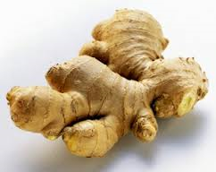
Ginger Nutrition:
- Excellent source of B vitamins and Vitamin C
- Excellent source of potassium, manganese, copper and magnesium
- Low in fat and calories
- Contains numerous anti-inflammatory and antioxidant compounds beneficial to health such as gingerols, beta-carotene, and capsaicin
Team Ginger …
You can grow your own ginger indoors in pots by using ginger knots from the grocery store
Ginger can be harvested from 4-12 months of growing
Ginger is not a root, it is an underground stem of the plant
Ginger is a tropical plant
Ginger is an herb
Ginger has a long history for medicinal use, treating nausea, motion sickness and loss of appetite
You can cook with fresh ginger, powdered spice ginger, or ginger oil
Ginger produces a hot, fragrant kitchen spice
You can chew on a quarter piece of raw ginger to help treat nausea

Ginger
When purchasing fresh ginger, make sure it is firm, smooth and mold-free. Store fresh ginger in a tightly wrapped plastic bag in the refrigerator or freezer
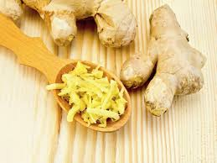
Enjoy fragrant ginger….
…Ginger pairs well with fish, pork, pumpkin and apples
…add into your next smoothie
…add fresh or dried to your next stir-fry or homemade dressing
…Steep peeled fresh ginger into boiling water to make ginger tea, with added honey or orange peel

