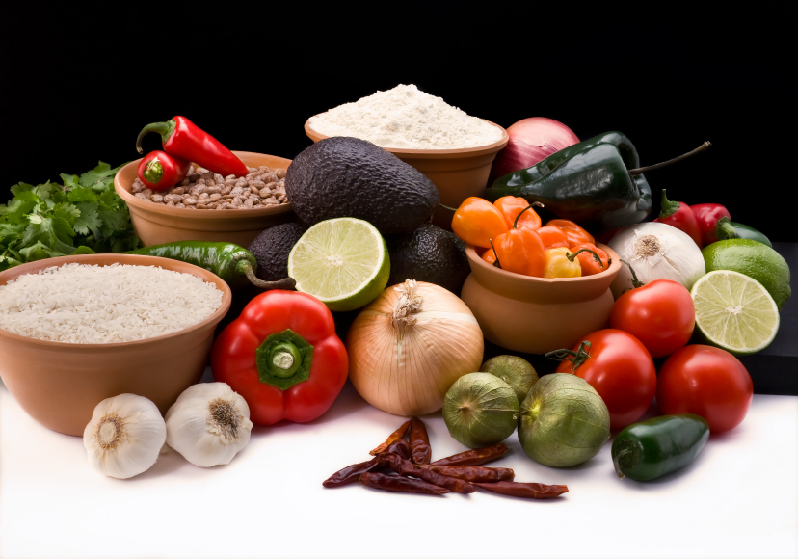
Recipe for: Spicy Ginger Roasted Carrots

6 carrots, peeled and sliced1/8 tsp cayenne
1 T cinnamon½ T olive oil
½ tsp ginger
½ tsp garlic powder
½ tsp paprika

Combine/toss spices and carrots to coat well. Place in oven safe baking dish. Bake at 400 degrees for 20 minutes, stir and bake another 20 minutes.
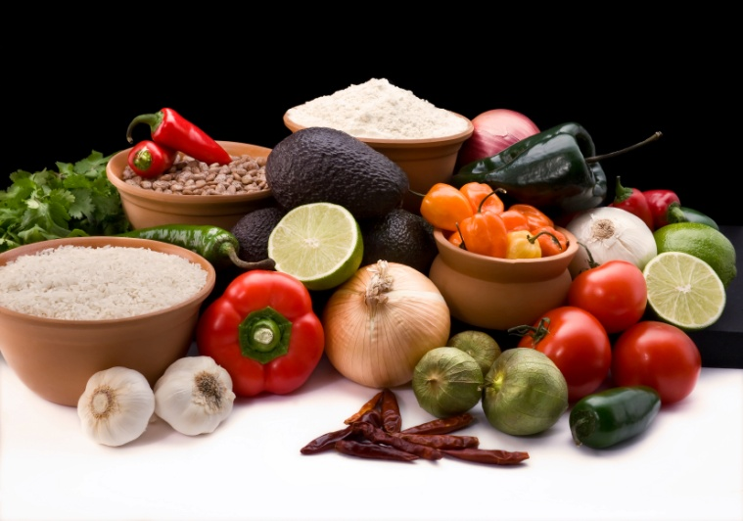

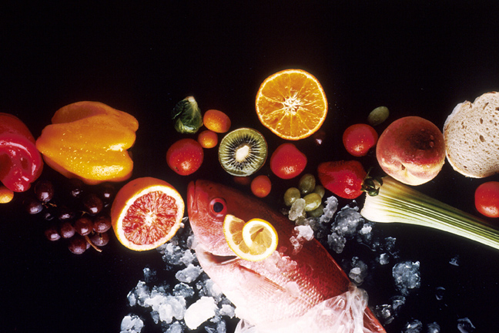
Recipe for: Roasted Pumpkin Ginger Soup

1 medium pie pumpkinCanola oil
2” fresh ginger, peeled and grated Fresh thyme
1 onion, choppedFresh sage
4 carrots, chopped1 tsp cinnamon
2 garlic cloves, mincedSalt & Pepper to taste
3 c stock of choiceOptional garnish: pumpkin seeds
Cut pumpkin in half and scoop out seeds, coat with oil, salt and pepper, bake cut side down 1 hr at 375F. Cool, scoop out flesh. In a large soup pot, heat oil and sauté onion, carrot and garlic. Add broth, pumpkin and spices. Cook 20 minutes. Puree soup with either an immersion blender or by small batches in a blender. Garnish with seeds if desired.
Recipe for: Sesame Ginger Quinoa Salad

1 cup quinoa, rinsed½ yellow pepper, diced
2 c water½ red pepper, diced
¼ tsp salt1 c red cabbage, chopped
1 ½ c shelled, frozen edamame 2 T sesame oil
3 medium carrots, diced2 T rice vinegar
1 T fresh ginger, minced1 T sesame seeds

Cook quinoa, water and salt in covered pot about 15 minutes. Pour into bowl and mix with vegetables. Make dressing by mixing oil, vinegar, ginger and sesame seeds. Pour over vegetables, enjoy immediately.
Recipe for: Soft & Chewy Ginger Cookies

2 ¼ c flour¾ c unsalted butter, softened
½ tsp ground cloves1 c sugar
1 tsp ground ginger¼ c dark molasses
1 tsp cinnamon1 large egg
2 tsp baking soda
½ tsp salt

Mix dry ingredients together, set aside. Cream butter and sugar together until creamy, add molasses and egg, mix well. Add dry ingredients, mix well. Chill dough for 1 hr. Roll dough into 1 inch balls and roll in granulated sugar. Place on cookie sheets, bake 8-10 minutes. Makes ~2 dozen.
Recipe for:

Recipe for:

