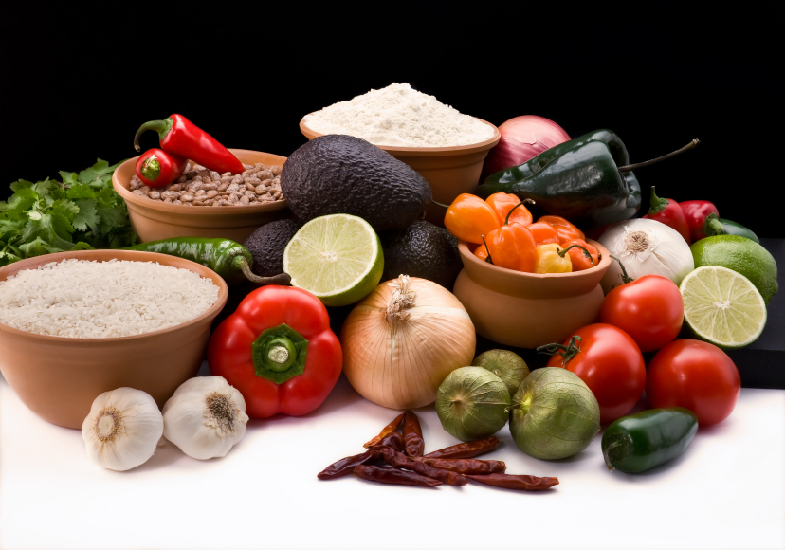
Recipe for: Roasted Garlic Pesto

4 heads garlic
4 sprays olive oil cooking spray
2 cups fresh basil leaves
1 teaspoon pine nuts

Preheat oven to 375 degrees F. Cut tops off garlic. Lightly spray each with cooking oil spray. Wrap in aluminum foil and roast for 1 hour. Let cool before handling. Squeeze pulp from garlic into a food processor. Add basil and pine nuts and pulse until smooth.

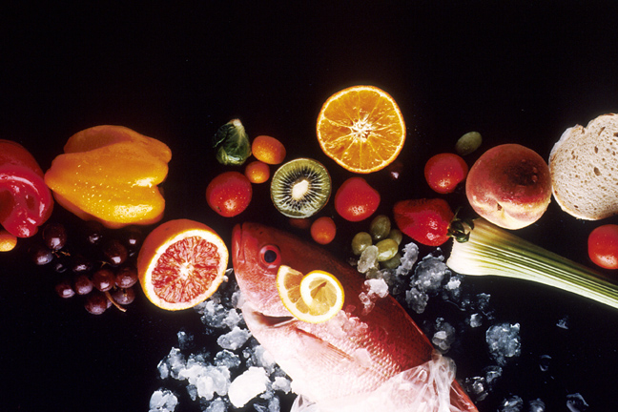
Recipe for: Roasted Garlic Hummus

1 can chickpeas/garbanzo beans (15 oz.)
2 tablespoons roasted garlic
1/2 tablespoon lemon juice
1 tablespoon olive oil
1/2 teaspoon oregano

In a food processor, process beans, garlic, olive oil, lemon juice and oregano until desired consistency. If hummus is too thick, simply add olive oil in small increments (1/2 teaspoon) until desired consistency.

Serve roasted garlic hummus garnished with finely chopped parsley with hot pita bread, pita chips, or veggies. Hummus can be prepared in advance up to two days if stored in airtight container in the refrigerator.

Recipe for: Roasted Garlic Zucchini & Tomatoes
2 zucchini cut in half lengthwise, then into ½ inch half moons
2 cups quartered ripe tomatoes
½ onion, minced
3 cloves garlic, minced
½ teaspoon crushed red pepper flakes (can use sweet bell pepper or cayenne pepper flakes)
¼ cup olive oil
salt and pepper to taste
½ cup grated Parmesan cheese
1 tablespoon chopped fresh basil

Preheat oven to 450° F. Lightly grease a 9x13 inch baking dish.
Combine the zucchini, tomatoes, onion, garlic, and red pepper flakes in the prepared baking dish. Drizzle with the olive oil, season with salt and pepper, and mix well.
Place in preheated oven. Roast until vegetables are tender and slightly golden, about 18 minutes. Remove from oven; sprinkle with the Parmesan cheese and basil.

Recipe for: Creamy Roasted Garlic Hummus

2 cups, canned or cooked chickpeas, drained and rinsed
2 tablespoons tahini
4 tablespoons olive oil
¼ cup warm water
1 large head of garlic, roasted
1 lemon, juice of
1/4 teaspoon sea salt

Using your fingers, squeeze the soft, roasted garlic out of each clove into food processor. Add chick peas and all other ingredients to the food processor and blend until completely smooth. If the hummus is too thick, add additional olive oil very slowly, allowing the mixture to combine fully before adding more liquid.

