Let’s Get More Flax Seed!

Ground flax seed, it can easily be added to any of the following…
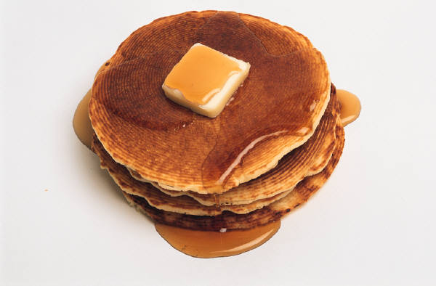
- Yogurt
- Hot cereal
- Applesauce
- Cottage cheese
- Fruit , breakfast, or protein smoothies
- Green salads or potato, tuna, or egg salad
- Soups, beans, chili, or mashed potatoes (after cooked)
- Muffins, breads, waffles, and pancakes
- Use flaxseed as an egg substitute in Meatloaf and Hamburgers!

Keep in mind that when adding ground flax seed to a product that requires preparation, do not add it until after the product has been heated and prepared. You can make sprinkling the ground flax as your final touch!

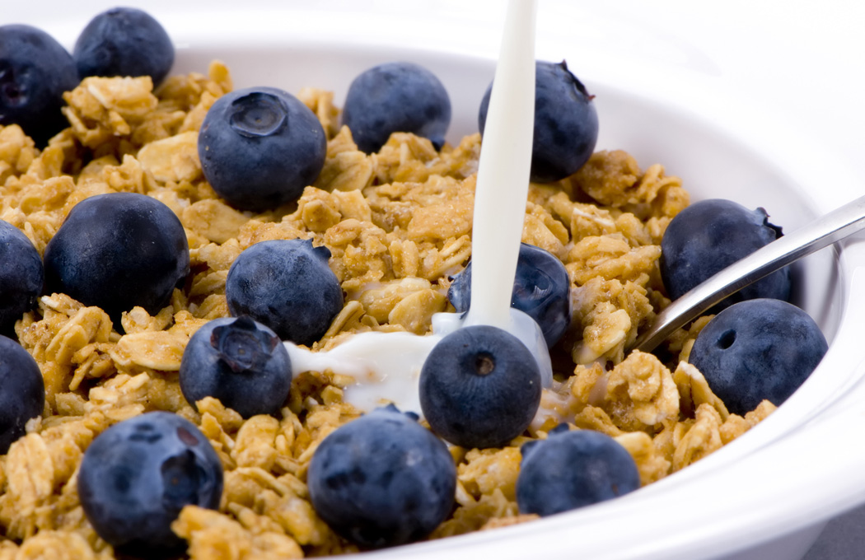
Let’s Get More Flax Seed!

Ground flax seed, it can easily be added to any of the following…
- Yogurt
- Hot cereal
- Applesauce
- Cottage cheese
- Fruit , breakfast, or protein smoothies
- Green salads or potato, tuna, or egg salad
- Soups, beans, chili, or mashed potatoes (after cooked)
- Muffins, breads, waffles, and pancakes
- Use flaxseed as an egg substitute in Meatloaf and Hamburgers!

Keep in mind that when adding ground flax seed to a product that requires preparation, do not add it until after the product has been heated and prepared. You can make sprinkling the ground flax as your final touch!

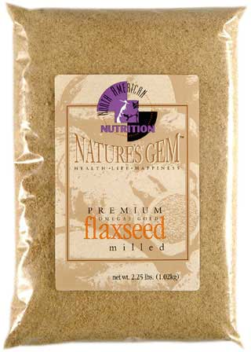
What do I gain from this Flax Seed stuff anyway?

Nutritional benefits

1. Omega 3 Fatty Acids, the GOOD FATS!
* Fight inflammation in our bodies
* Protects against Heart disease
2. Fiber rich
* Lowers cholesterol
* Stabilize blood sugar
* Proper functioning of our
stomachs!!!
3. Phytochemicals (phyto = plant)
* Boost our immune systems
* Reduces the risk of cancer

What do I gain from this Flax Seed stuff anyway?

Nutritional benefits

1. Omega 3 Fatty Acids, the GOOD FATS!
* Fight inflammation in our bodies
* Protects against Heart disease
2. Fiber rich
* Lowers cholesterol
* Stabilize blood sugar
* Proper functioning of our
stomachs!!!
3. Phytochemicals (phyto = plant)
* Boost our immune systems
* Reduces the risk of cancer
Chocolate Chip Flax Seed Cookies!!

Ingredients:
1 C. Shortening 1 tsp. baking soda
1 C. Brown sugar ½ salt
½ C Granulated Sugar 1 C Chocolate
1 tsp. Vanilla chips
2 Eggs beaten ¼ C. Ground
2 C. all purpose flour flax seed

Directions
Preheat oven to 350 degrees
In large bowl, cream shortening and sugars
Add vanilla and beaten eggs
In separate bowl, combine flour, baking soda, chocolate chips and ground flax
Drop by teaspoonful onto a cookie sheet, leaving 2 inches between cookies
Bake 10 to 12 minutes, or until golden
Remove from sheet, cool, and enjoy

Chocolate Chip Flax Seed Cookies!!

Ingredients:
1 C. Shortening 1 tsp. baking soda
1 C. Brown sugar ½ tsp. salt
½ C Granulated Sugar 1 C. Chocolate
1 tsp. Vanilla chips
2 Eggs beaten ¼ C. Ground
2 C. all purpose flour flax seed

Directions
Preheat oven to 350 degrees
In large bowl, cream shortening and sugars
Add vanilla and beaten eggs
In separate bowl, combine flour, baking soda, chocolate chips and ground flax
Drop by teaspoonful onto a cookie sheet, leaving 2 inches between cookies
Bake 10 to 12 minutes, or until golden
Remove from sheet, cool, and enjoy

