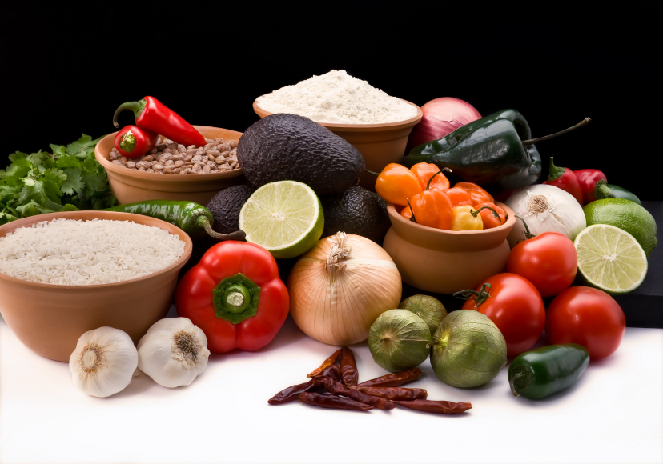
Recipe for: Bess’ Best Tuna/Salmon Patty
3 oz Canned Tuna or Salmon
1 egg white
½ Tablespoon dried onion flakes
Pepper to taste

Mix all ingredients together. Form into a patty and fry in a non-stick skillet until golden brown.

Variations: Use leftover potato in place of egg white for binding.
For more bulk add ¼ cup whole wheat bread crumbs.
Add different spices to vary the flavor.

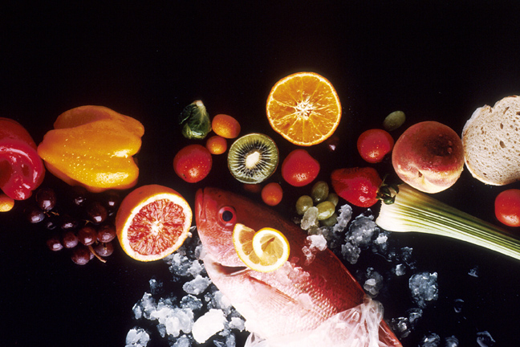
Recipe for: Parmesan Baked Tilapia

4 oz tilapia fillet (or other white fish) ½ tablespoon lemon juice
1 tablespoon reduced fat/light mayonnaise 1 green onion, finely chopped
1 ½ tablespoons grated parmesan Dash dried basil
Salt and pepper to taste

Preheat oven to 350 F. Place fish on a greased baking dish. Brush the top with lemon juice. Bake fish 10 to 20 minutes or until fish just starts to flake (cooking time will depend on thickness of fillet). Meanwhile combine mayo, onions, parmesan and seasonings in a bowl; mix well with fork. When fish is done cooking spread top with cheese mixture and bake an additional 5 minutes or until golden brown. Try it served with marinara sauce.

Recipe for: Baked White Fish w/ Mushrooms

6 white fish fillets1 cup chopped mushrooms
½ cup whole wheat bread crumbs¼ teaspoon garlic powder
2 tablespoons lemon juice1 tablespoon soy sauce
¼ teaspoon paprikaSalt and pepper to taste

Preheat oven to 350 F. Place fish fillets in baking dish. Top with mushrooms and bread crumbs. Drizzle with lemon juice and soy sauce and sprinkle w/ seasonings. Bake 15-20 minutes until fish is done (time may vary depending on thickness of fish filets).

Recipe for: Honey and Soy Glazed Salmon

2 tablespoons honey1 tablespoon water
2 tablespoons low sodium soy sauce1 ½ tablespoon lime juice
2 teaspoons prepared mustard2 teaspoons canola oil
2 salmon filets (4-6 oz each)

In a small bowl whisk together honey, water, soy sauce, lime juice, and mustard. In a non-stick skillet, heat oil over medium-high heat until hot. Cook salmon 3-4 minutes on each side or until golden and cooked through (cooking time will depend on thickness of filets). Transfer salmon to a plate. Add honey mixture to skillet and simmer for 1 minute, to create a glaze, stirring frequently. Pour glaze over salmon and enjoy.

