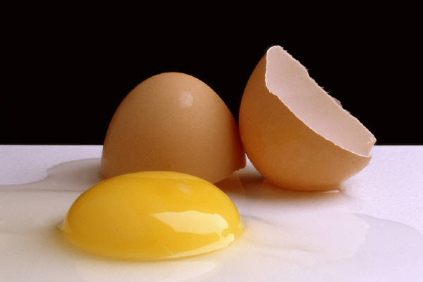
Eggs
The question: Is an egg good?
Yes it is!! And here’s why?
- Only 71 calories & 6 grams of protein

- Excellent source of vitamins and minerals, including Vitamin D

- Does not raise the ‘bad’ cholesterol

- Affordable and Versatile!!!
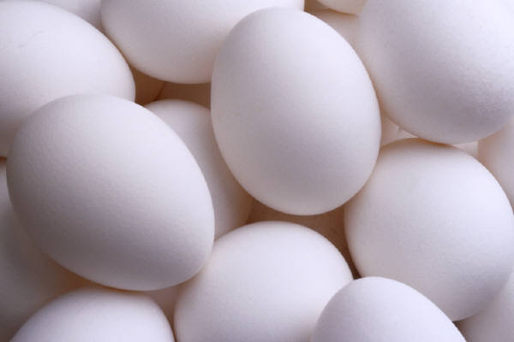

Things to Know…
Eggs are high-quality, complete protein and the ‘Gold Standard’ (all other protein sources are compared to it)!
High-quality protein has been shown to reduce calorie intake, keep you full and energized, and help build and keep muscle mass. Anti-oxidants found in egg yolks have been shown to reduce development of cataracts.
Vitamin D, a major nutrient in bone health, can be found in eggs, one of its FEW natural food sources.
When buying eggs, if the price increase for the next larger size is 7 cents or less/dozen, then the larger size is a better deal because you get more egg for your money.
Refrigerate eggs at 45 degrees Fahrenheit or less when purchased. Keep eggs refrigerated until use. Keep a maximum of two weeks supply of eggs, and rotate your stock.
You can poach, scramble, serve sunny-side up or over easy, hard- or soft-boiled, baked or fried.
Created by Brent Haugle, UW-Stout Dietetic Intern February 2013

