
Recipe for: Bittersweet Chocolate Pudding
1/3 cup unsweetened cocoa½ cup sugar
3 T cornstarch3 T dark brown sugar
Dash salt4 cups reduced fat milk
3 large egg yolks, lightly beaten2 oz bittersweet chocolate, chopped
1 t vanilla extract

Combine cocoa, sugars, cornstarch and salt in large saucepan. Gradually add milk, stirring with whisk. Bring to a boil over medium heat, stirring constantly. Cook 1 minute.

Place egg yolks in a bowl. Very gradually add hot milk mixture to egg yolks stirring constantly. Return milk mixture to pan. Cook over medium heat 5 minutes or until thick, stirring constantly. Remove from heat, add chocolate and vanilla and stir until chocolate melts. Thoroughly chill before serving.

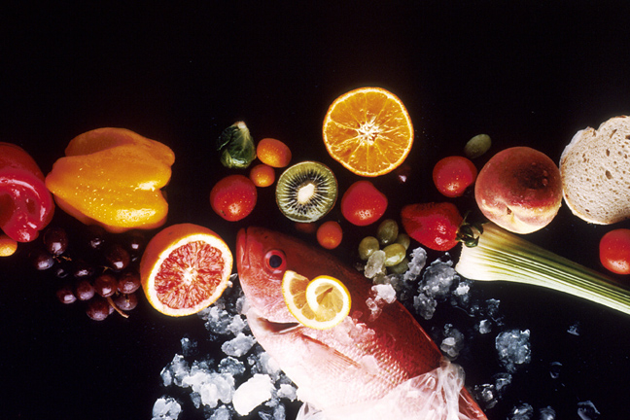
Recipe for: Bittersweet Chocolate Mousse a l’Orange
½ cup sugar
7 T unsweetened cocoa
2 T Grand Marnier (orange-flavored liqueur)
1 t grated orange rind
½ t vanilla extract
Dash of salt
2 -12.3 oz packages reduced fat silken tofu, drained
3 oz bittersweet chocolate, chopped
3 oranges, peeled and sectioned

Combine first seven ingredients in blender or food processor until smooth. Place chopped chocolate in small microwave safe bowl. Microwave on HIGH 1 minute or until almost melted. Stir until smooth. Add chocolate to tofu mixture and process until smooth. Divide orange sections evenly among 6 bowls or parfait glasses. Top with ½ cup mousse. Chill at least 1 hour before serving.

Recipe for:

Recipe for:

