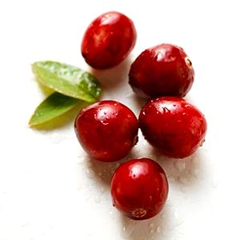

Cooking with Cranberries

Cook cranberries only until they pop because overcooking will give them a bitter taste.
Combine fresh cranberries with other fruits such as oranges, apples, pineapples, or pears to balance their extreme tartness.
Mix dried cranberries with lightly roasted nuts for a delicious snack.
Add dried cranberries to hot oatmeal or to any cold cereal for a tangy twist on breakfast.
Add a little color to rice pudding, quick breads, or muffins by
using dried cranberries instead of raisins.
Drink 100% juice blends that include cranberry juice.

Crazy for Cranberries

The cranberry is the state fruit of Wisconsin.
There is disagreement as to whether or not cranberries
were served at the first Thanksgiving.
Cranberries are one of only three fruits that are native to North America, along with the blueberry and Concord grape.
Cranberries, especially cranberry juice, have been shown to lower the risk of urinary tract infections in women.
Sailors once used cranberries as a source of vitamin C to prevent scurvy.
Cranberries were first named “crane berries” because the plant’s flowers dip down and resemble the head of a crane.

Written and created by Robyn Verschay, UW-Stout Dietetic Intern, 9/2009
Beneficial Bites
Beneficial Bites

