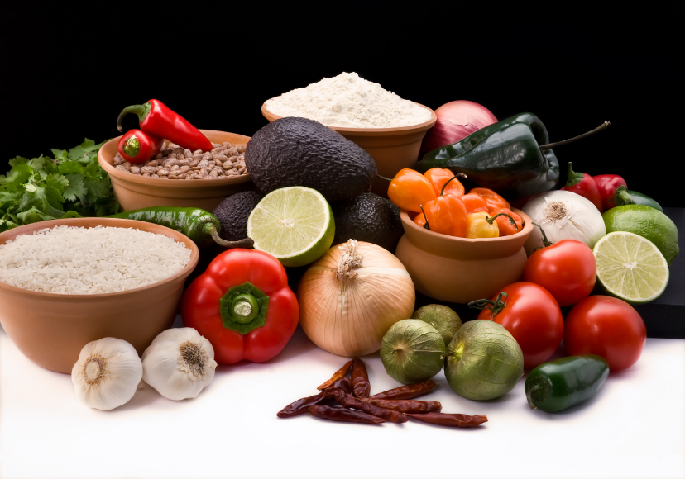
Recipe for: Cranberry Meatballs
1 # ground beef½ cup bread crumbs
1 egg, beaten1 tablespoon soy sauce
¼ teaspoon garlic powderDash black pepper
2 ½ tablespoons ketchup

Mix together above ingredients. Form into small balls, place on baking sheet and bake for 30 minutes at 350°F.

1 cup jellied cranberry sauce1 cup barbecue sauce
1 T. brown sugar½ T. lemon juice

In saucepan over low heat, combine cranberry sauce, barbecue sauce, brown sugar and lemon juice. Simmer and stir until smooth. Add meatballs and simmer for at least 1 hour before serving.

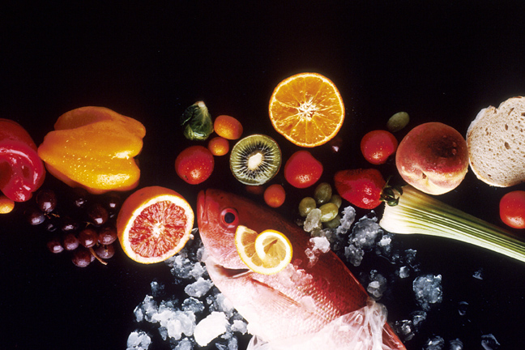
Recipe for: Cranberry Waldorf Salad
1 cup chopped fresh cranberries
1 cup chopped red or green apple
1 cup chopped celery
1 cup red or green seedless grapes, halved
¼ cup walnut pieces
¼ teaspoon ground cinnamon
8 ounces vanilla low-fat yogurt
¼ - ½ teaspoon vanilla extract

Combine cranberries, apple, celery, grapes and walnuts in medium serving bowl. In small bowl combine cinnamon, yogurt and extract. Drizzle over the other ingredients and toss to blend. Serve immediately.
Recipe for: Holiday Cranberry Yeast Bread

1 ½ cups fresh or frozen cranberries, halved1/3 cup molasses
1/3 cup packed brown sugar

1 ¼ cups warm water (110-115°F), divided1 tablespoon active dry yeast
1 tablespoon honey2 tablespoons butter, melted
1 teaspoon salt¼ teaspoon ground allspice
2 ½ cups whole wheat flour1 ½ - 2 cups all-purpose flour

In small bowl, combine cranberries, molasses and brown sugar. Let stand 1 hour then stir in 1 cup warm water. In large bowl, dissolve yeast in remaining warm water. Add honey; let stand 5 minutes. Beat in butter, salt, allspice, whole wheat flour, 1 cup all-purpose flour and cranberry mixture until smooth. Stir in enough remaining flour to form soft dough. Turn onto lightly flour surface; knead until smooth and elastic (6-8 minutes). Place in large greased bowl turning once to coat top. Cover, let rise until doubled. Punch down, turn onto floured surface and shape into loaf. Let rise again until doubled then bake at 400° for about 50 minutes. Taste of Home website

Recipe for: Cranberry Nut Bars
2 eggs
1 cup sugar
1 cup flour
1/3 cup butter or margarine, melted
1 ¼ cup fresh or frozen cranberries
½ cup chopped walnuts

Preheat oven to 350. Grease 8” baking pan. Beat eggs in medium bowl until thick. Gradually add sugar, beating until thoroughly blended. Stir in flour and melted butter; blend well. Add cranberries and walnuts. Spread in pan. Bake 40-45 minutes or until golden brown and toothpick inserted comes out clean. Cool.

