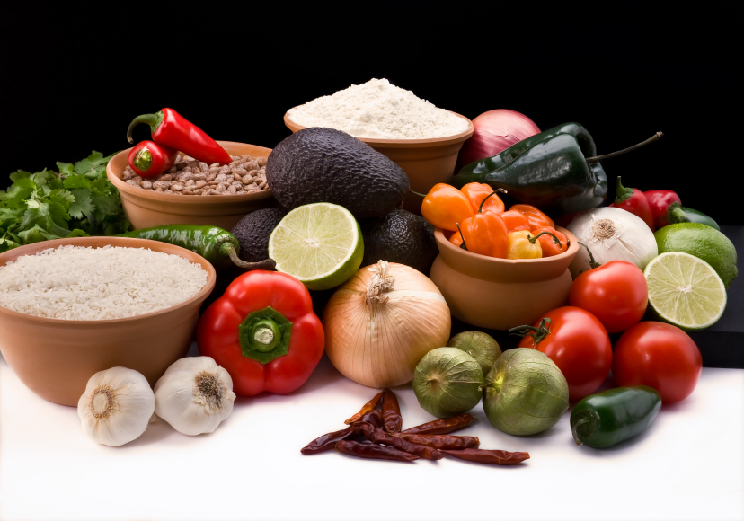
Recipe for: Cranberry Corn Bread
½ cup butter, softened
1 cup sugar
2 eggs
1 ½ cups all-purpose flour
1 cup cornmeal
2 tsp baking powder
1 ½ cups buttermilk
1 cup cranberries, halved

In a mixing bowl, cream butter & sugar. Add eggs; mix well. Combine the flour, cornmeal, baking powder, & salt. Add to creamed mixture alternately with buttermilk. Fold in cranberries. Transfer to a 9-inch square baking pan. Bake at 375 degrees F for 40-45 minutes or until a toothpick inserted near the center comes out clean.

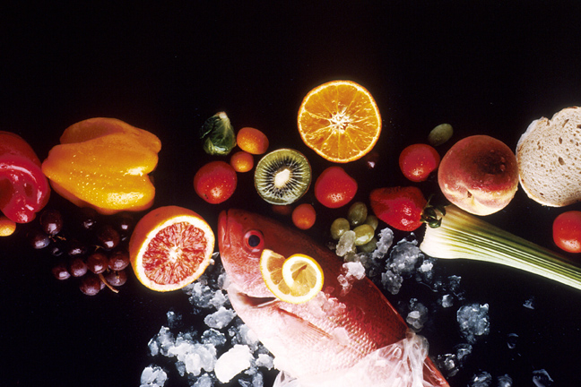
Recipe for: Cranberry Spinach Salad

1 (6 ounce package) fresh spinach
1/3 cup dried cranberries
1/3 cup chopped walnuts
1/3 cup raspberry walnut vinaigrette
1 tbsp finely shredded Romano cheese

Combine the spinach, cranberries, walnuts, vinaigrette, and Romano cheese in a large bowl; toss until spinach is evenly coated. Serve immediately.

Recipe for: Cranberry Glazed Carrots

8 cups sliced carrots
4 T bottled light raspberry or cranberry vinaigrette dressing
½ cup canned whole cranberry sauce
¼ cup chopped toasted pecans

Combine carrots, vinaigrette and cranberry sauce to a medium-large non-stick saucepan and bring to a boil. Reduce heat to low and cover pan. Simmer 8-10 minutes or until carrots are tender, stirring occasionally. Spoon into serving bowl and sprinkle pecans over the top.

8-10 servings; 89 calories; 16.5 gms carbohydrate; 3.7 gm fat; 3.5 gm fiber

Recipe for: Cranberry Meat Glaze

1 pkt dry onion soup mix
1 can whole cranberry sauce
½ cup Catalina dressing

Combine all ingredients and let stand 10 minutes. Pour over chicken or pork during baking or serve warm/cold along side for dipping into. Also makes a great spread on sandwiches when using leftovers.

Recipe courtesy Carla TePaske, Cameron Senior Dining Manager

