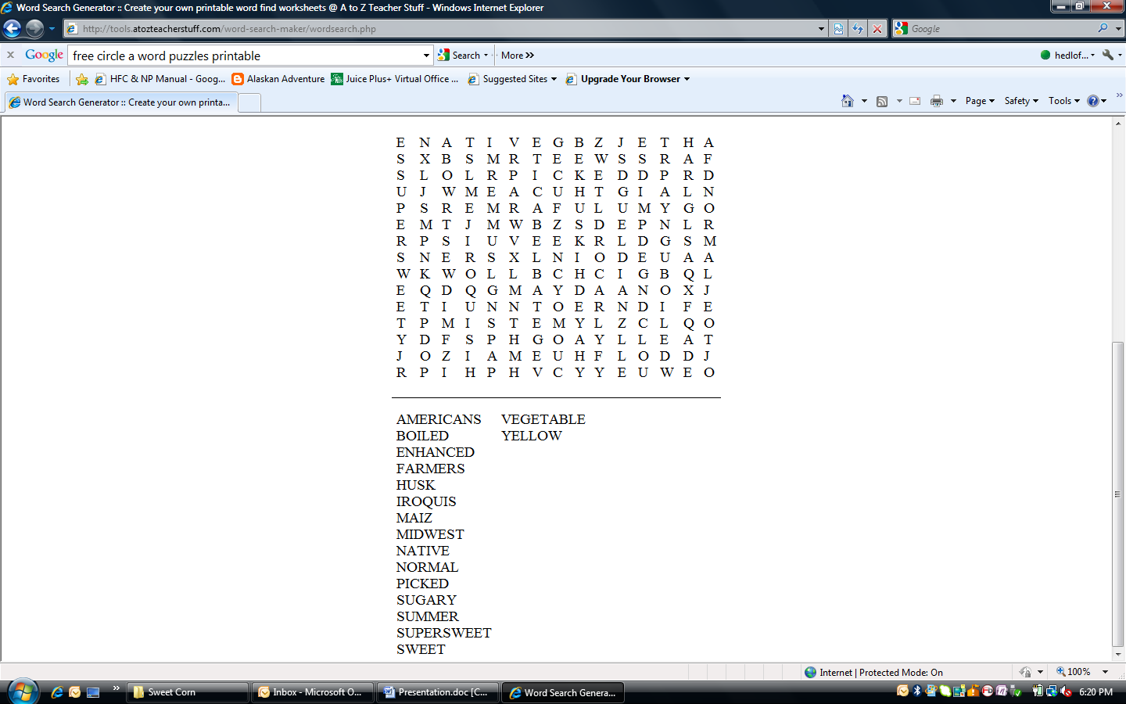

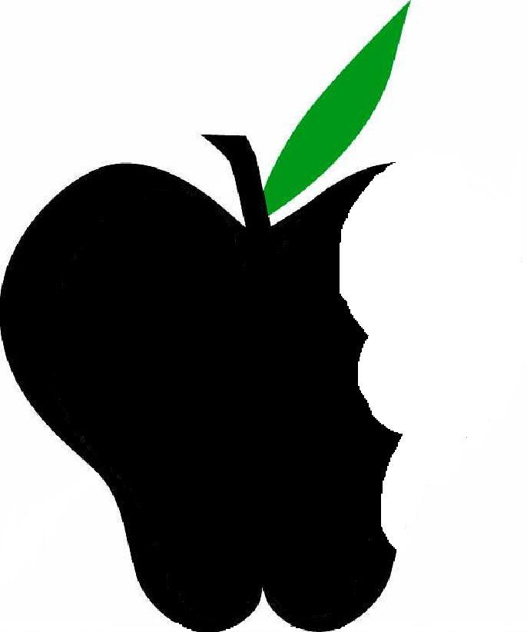
AmericansMidwestSummer
BoiledNativeSupersweet
EnhancedMidwestSweet
FarmersNativeVegetable
HuskNormalYellow
IroquisPicked
MaizSugary
Word Bank
Circle the Words
AmericansMidwestSummer
BoiledNativeSupersweet
EnhancedMidwestSweet
FarmersNativeVegetable
HuskNormalYellow
IroquisPicked
MaizSugary
Word Bank
Circle the Words
Beneficial Bites
Beneficial Bites
Puzzle created by Lisa Hedlof
UW-Stout Dietetics Student July 2011
Puzzle created by Lisa Hedlof
UW-Stout Dietetics Student July 2011

