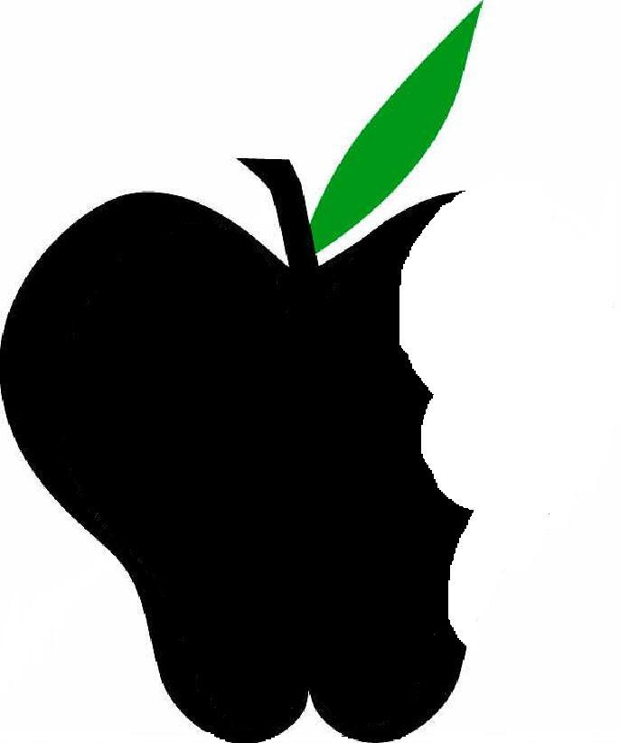
Beneficial Bites
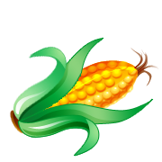
Sweet Corn
Sweet corn is a vegetable that has been around in the United States and Mexico for a very long time. Native Americans were the first to introduce it to the European Settlers.
Corn is grown all throughout the United States but more specifically in the Midwestern region of the country. There is a section of the United States called the corn belt which includes Michigan, Minnesota, South Dakota, Wisconsin, Ohio, Kansas and Nebraska. These states grow over 35% of the world’s corn.
Corn is also grown in China, Argentina, Brazil, France, Mexico, Romania and Africa.
Types of Sweet Corn
Do you know the sweet corn code?
SU
Normal Sugary-best suited for being picked, husked, and eaten within a short period of time
SE
Sugary enhancer- tender and creamy texture with the same sweetness as SU. This type is superior to all others.
Sh2
Supersweet- higher sugar content than the standard but less than SE. This type of corn needs to be tasseled and separated from the other corn when grown and reaching maturity.

How do you enjoy sweet corn?
Beneficial Bites

Corn can be made into many different things. Some people like to boil or grill sweet corn and eat it right off the cob.

Processing decreases the nutrient density of corn. Certainly candy corn and corn chips aren’t going to provide health benefits but it’s okay to enjoy these once in awhile. Yum!
Lisa Hedlof
UW-Stout Dietetics Student
July 2011

