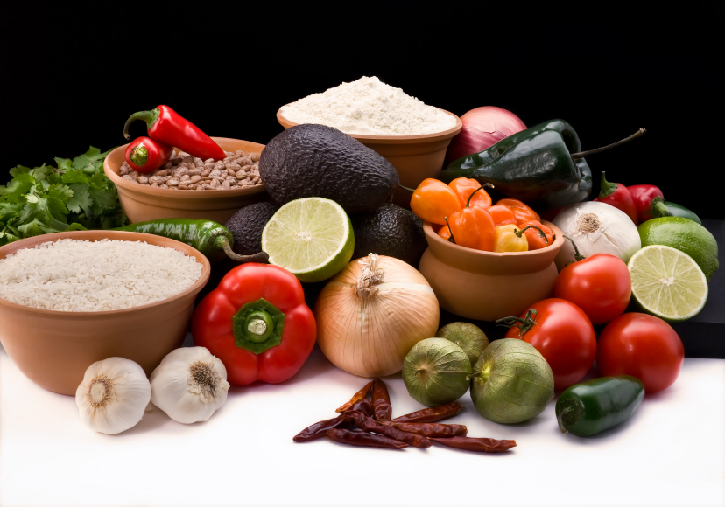
Recipe for: Quick Red Pepper Corn
3 cups fresh or frozen corn
½ cup chopped sweet red pepper
2 tablespoons maple syrup
Salt & pepper to taste
Dash chili powder (optional)

Combine corn and red peppers in microwave safe bowl. Cover and microwave on high for 5-8 minutes or until corn is tender. Drain off any liquid. Add maple syrup and seasonings and toss gently. Serve immediately.

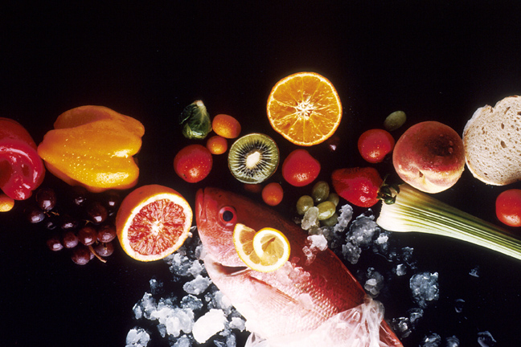
Recipe for: Fifteen Minute Bean Soup
1 can (16 oz) regular or spicey refried beans
1 can (15-16 oz) whole kernel corn, drained
1 can (15-16 oz) black beans, rinsed and drained
1 can (14-15 oz) chicken broth
1 can (14-15 oz) stewed tomatoes, diced
½ cup water
1 can (4 oz) chopped green chilis
¼ cup salsa

Combine all ingredients in large saucepan. Bring to a boil, reduce heat and simmer uncovered for 8-10 minutes. Serve with tortilla chips, a dollop of sour cream and shredded cheddar cheese.

Use low-fat, fat-free and/or sodium free products to accommodate your dietary needs!

Recipe for: Cheesy Corn Chowder
6 strips bacon, chopped¾ cup chopped onion
2 ½ cups chicken broth2 ½ cups cubed peeled potatoes
2 cups sliced fresh carrots3 cups fresh or frozen corn
½ teaspoon pepper7 tablespoons flour
5 cups milk3 cups shredded cheddar cheese
1 cup cubed Velveeta-type cheese

In skillet, cook bacon. Remove to paper towel. Drain all but 1 tablespoon grease and sauté onions until tender. In large pot, combine broth, carrots and potatoes. Bring to a boil then reduce heat. Simmer until potatoes and carrots are fork tender but not mushy, about 10-12 minutes. Add corn and pepper. In another bowl, whisk flour with milk until smooth. Add to soup and bring to boil again. Cook, stirring constantly until thickened. Remove from heat and add cheeses. Stir until cheeses melt (return to low heat if necessary). Serve immediately.
Recipe for: Cool Beans Salad
3 cups cooked converted rice4 green onions sliced
1 (16 oz) can dark red kidney beans1 (15 oz) black beans, rinsed and drained
1 ½ cups frozen corn, thawed1 small red sweet bell pepper, diced
Optional, ¼ cup minced fresh cilantro

In large bowl, fluff rice before combining with remaining above ingredients. Whisk together dressing ingredients in small bowl. Pour over salad and toss lightly to coat. Chill 1-2 hours before serving. (If rice is very sticky, combine the rice with the dressing before adding to other salad ingredients.)
DRESSING: ½ cup olive oil, ¼ cup red wine vinegar, 1 tablespoon sugar, 1 garlic clove minced, 1 teaspoon ground cumin, 1 teaspoon chili powder, salt & pepper

Recipe for: Corny Bean Salad
1 can each of the following, drained and rinsed:
kidney beans, cut green beans, cut wax beans and whole kernel corn
2 ribs celery, thinly sliced
1 medium green pepper, chopped
½ cup sweet red pepper, chopped
½ cup sliced ripe olives
½ cup sliced green onions

Combine all ingredients above. In small bowl whisk together dressing ingredients until sugar is dissolved. Pour over bean mixture, toss to coat, cover and refrigerate overnight.

DRESSING: 1 cup sugar, 1 cup white vinegar, 2 tablespoons canola oil, ½ teaspoon ground mustard, salt and pepper. (Sugar will dissolve a little easier if vinegar is slightly lukewarm.)

Recipe for: Creamed Corn
Not exceptionally nutritious but certainly delicious!

2 packages frozen corn
8 oz cream cheese, softened and cubed (low fat okay)
3 tablespoons butter
1 tablespoon sugar
Salt

In small slow cooker coated with cooking spray, combine all ingredients. Cover and cook on low for 3-3 ½ hours or until cheese is melted, and corn is tender and creamy. Stirring occasionally.

Feel free to add other spices or diced bell peppers.

Recipe for: Roasted Corn & Garlic Rice
2 ears sweet corn in husks
1-2 garlic cloves, minced
1 teaspoons olive oil
½ cup uncooked long grain brown rice
1 cup chicken broth
1 bay leaf
Salt and pepper

Remove silk from corn and rewrap with husks. Place on grill or in 400° oven for 20-30 minutes. Meanwhile, combine rice, broth, bay leaf, oil and minced garlic in sauce pan. Bring to a boil, reduce heat, cover and allow to cook for 20 minutes. (you may want to remove from heat for first 5-10 minutes to prevent scorching. When corn is done, remove from cob. Lightly toss with cooked rice, remove bay leaf and serve immediately.
Recipe from Taste of Home website www.tasteofhome.com

Recipe for: Down Home Succotash
¼ # sliced bacon, chopped
2 cups fresh or frozen corn
1 cup lima beans (if using canned, be sure to drain and rinse)
1 medium green pepper, chopped
1 medium onion, chopped
2 medium tomatoes, diced

In large skillet, cook bacon until crisp. Remove bacon and pat with paper towels. Drain all but 1 tablespoon bacon drippings, add onions and green pepper and sauté for 1 minute. Add corn and beans, simmering for 5-8 minutes or until vegetables are almost tender. Add a few tablespoons of water if necessary. Add tomatoes and bacon, lightly toss and cook just until tomatoes are heated.

