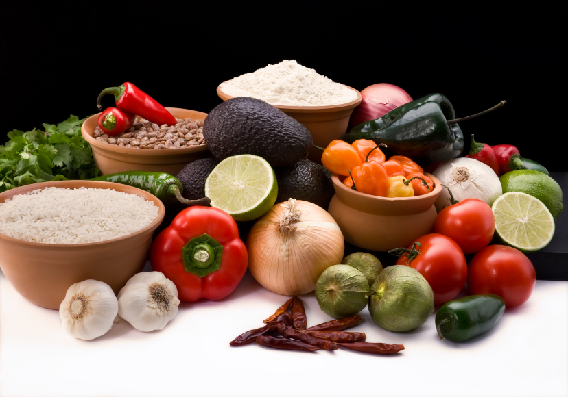
Recipe for: BBQ’d Corn on the Cob
6 ears of corn
½ cup butter, softened
1 teaspoon chili powder
Pinch each dried oregano & onion powder
Salt, pepper, garlic powder and cayenne pepper to taste

Pull back husks on corn to remove silk and rewrap with husks. Grill corn over low heat, turning regularly for 20-30 minutes or until tender. Meanwhile combine butter with seasonings. Just before serving, spread each cob with seasoned butter. MMmmm!

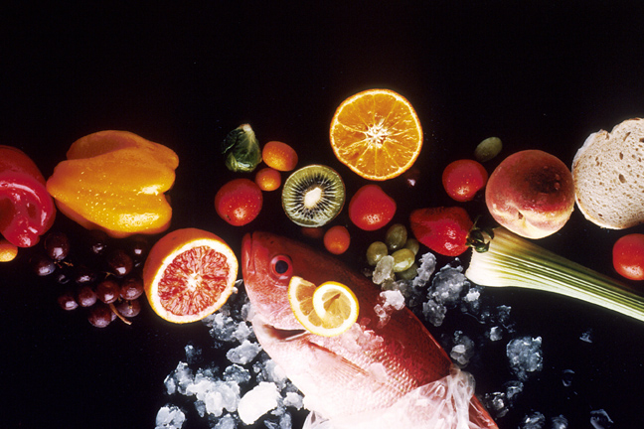
Recipe for: Sweet & Spicy Corn on Cob
6 ears of corn
2 tablespoons butter
4 garlic cloves, minced
1-2 teaspoons brown sugar
¼- ½ teaspoon crushed red pepper flakes
¼- ½ teaspoon chili powder

Pull back husks on corn to remove silk and rewrap with husks. (secure with string if necessary) Soak corn in cold water for 1 hour (grandma always said to sprinkle a little sugar in the water!) Grill corn over low to medium heat for 20-30 minutes turning often. Meanwhile, in small saucepan, melt butter. Add garlic, brown sugar, red pepper flakes and chili powder. When corn is done, remove husks and brush on buttery goodness.

Recipe for: Cornbread Casserole
1 can whole kernel corn, drained
1 can cream style corn
1 (8 ½ oz) package corn bread/muffin mix
1 egg
2 tablespoons butter, melted
¼ teaspoon garlic or onion powder
¼ teaspoon paprika
¼ cup diced sweet red pepper

In large bowl, combine all ingredients. Pour into greased 11 x 7 inch baking dish. Bake uncovered at 400°F for 25-30 minutes or until top and edges are golden brown. Serve immediately. Excellent side dish in place of potatoes or stuffing.
Recipe for: Old Fashioned Corn Relish
2 cups fresh or frozen corn2 cups chopped onions
2 cups chopped tomatoes2 cups chopped seeded cucumber
1 large green pepper1 cup sugar
1 cup cider vinegar1 ½ teaspoons celery seed
1 ½ teaspoons mustard seed½ teaspoon salt
½ teaspoon ground turmeric

In large saucepan, combine all ingredients. Bring to a boil. Reduce heat; simmer uncovered for 20-30 minutes or until thickened. Store in refrigerator for up to 3 weeks. Delicious with hotdogs!

