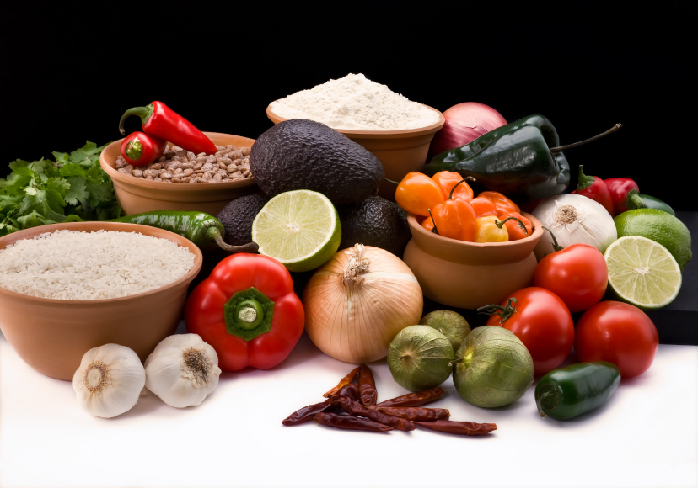
Recipe for: Dark Roast Baked Custard

¼ cup dark roast coffee beans2 ½ cups 1 % milk
4 eggs1/3 cup granulated sugar (or maple syrup)
¼ teaspoon salt1 teaspoon vanilla extract
Dash cinnamon or nutmeg

Crush coffee beans in Ziploc bag w/rolling pin. Place in medium saucepan, add milk and heat until steaming and tiny bubbles form around edges. Remove from heat and let stand 30 minutes. Pour coffee milk through cheesecloth-lined sieve into medium bowl. In large bowl, whisk egg, sugar (or maple syrup), salt and vanilla. Gently whisk in coffee-milk and skim foam. Pour into baking dish coated with cooking spray. Sprinkle with cinnamon or nutmeg. Bake about 40-50 minutes or until edges are set and knife inserted in center comes out clean. Cool before serving.
*Can also be baked in individual custard cups. Use water bath when baking individual cups.

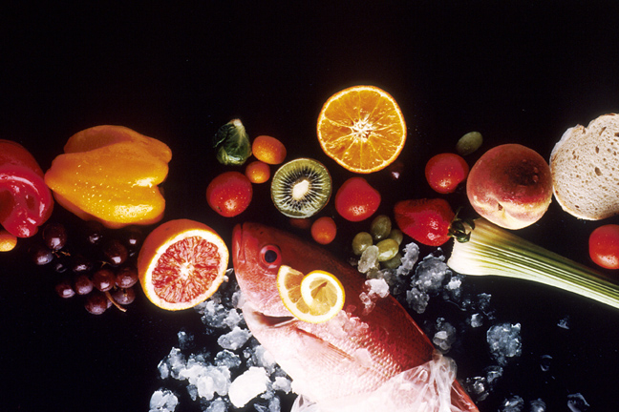
Recipe for: Tangy Baked “Coffee” Beans

4 strips cooked bacon, cut into ¾” pieces½ cup diced onion
1 cup diced sweet bell peppers, any color½ cup barbecue sauce
½ cup catsup¼ cup brown sugar
1 cup strong brewed coffee16 oz can dark kidney beans, drained, rinsed
16 oz can black beans, drained, rinsed16 oz can cannellini beans, drained, rinsed
28 oz can baked beans, slightly drained

Preheat oven to 350°. Coat large baking dish with cooking spray. Combine all ingredients in baking dish. Bake for 1 hour uncovered, stirring occasionally

Recipe for: Green (or Black) Tea Teriyaki Chicken

2-3 green or black tea bags1 cup boiling water
4 green onions, chopped3 tablespoons honey
2 tablespoons cider vinegar2 tablespoons low sodium soy sauce
4 garlic cloves, minced¼ teaspoon ground ginger
1 teaspoon canola oil4 boneless, skinless chicken breast halves (4 oz ea)

Steep tea bags in boiling water for 3-4 minutes. Remove bags and add half the onions, honey, vinegar, soy sauce, garlic, ginger and oil. Bring to boil, reduce heat and simmer uncovered until sauce is reduced to about ¾ cup. In the meantime, pound chicken breasts until about ½ inch thick. In large skillet, cook chicken over medium heat for 4-5 minutes on each side or until meat thermometer reads 170°. Pour sauce over chicken and simmer 5 minutes or so. Sprinkle with remaining green onions. Serve immediately.

Recipe for: Sparkling Tea & Cranberry Punch

6 cups water4 green tea bags
2 mint tea bags1 cup frozen cranberry juice concentrate
1 cup frozen orange juice concentrate½ cup lime juice
1 orange or lime sliced in wedges1 quart lemon-lime soda (sugar free is ok)

Bring water to boil. Add tea bags, remove from heat and let stand 3-4 minutes. Remove tea bags and cool tea in refrigerator.

When tea is chilled, mix with frozen concentrate juices and lime juice. Just before serving, add lemon lime soda. Garnish with sliced fruit.

Recipe for: Green Tea Asian Rice

2 cups hot water2 green tea bags
1 tablespoon honey2 tablespoons lower sodium soy sauce
1 cup rice (regular or converted)1 tablespoon vegetable oil
¼ cup toasted sliced almonds 2 tablespoons finely chopped green onions

Steep teabags in hot water for 2 minutes. Remove tea bags, add honey, soy sauce. oil and rice. Bring to a boil. Reduce heat to simmer, cover and continue cooking 20 minutes. Remove from heat entirely. Let stand another 5 minutes, fluff with fork while adding almonds and green onions.

Serve with stir fry or as a side dish to your main entrée.

Recipe for: Mocha Ice Pops
2 ½ cups hot brewed coffee
4-5 tablespoons sugar
2 tablespoons unsweetened cocoa powder
1 cup fat free half & half
¼ teaspoon vanilla extract
Pinch of salt

Whisk coffee, sugar (to taste) and cocoa in medium bowl until sugar has dissolved. Whisk in half and half, vanilla and salt until combined.

Divide mixture among freezer-pop molds. Insert the sticks and freeze until completely firm, about 6 hours. Dip molds briefly in hot water before unmolding.

Probably not the best evening snack and certainly not for an energetic grandchild!

