
Coffee…

How often do you remember waking up to the smell of hot coffee?

Coffee is actually made from small ground up seeds. If you place raw coffee seeds in the ground they will grow into a coffee tree. One tree will only produce 1-2 pounds of coffee per growing season.

Coffee is the second most traded commodity in the world second only to oil!

Health Benefits
Coffee has some pretty powerful health benefits which may include:
- Heart Disease and Stoke prevention
- Decreased risk for type II
Diabetes
- Certain Cancers
- Parkinson’s Disease in Men
Each year, 400 billion cups of coffee are consumed worldwide.

The history of this delicious beverage started with goats, yes goats, in the 9th century and still continues to be the most popular beverage consumed.
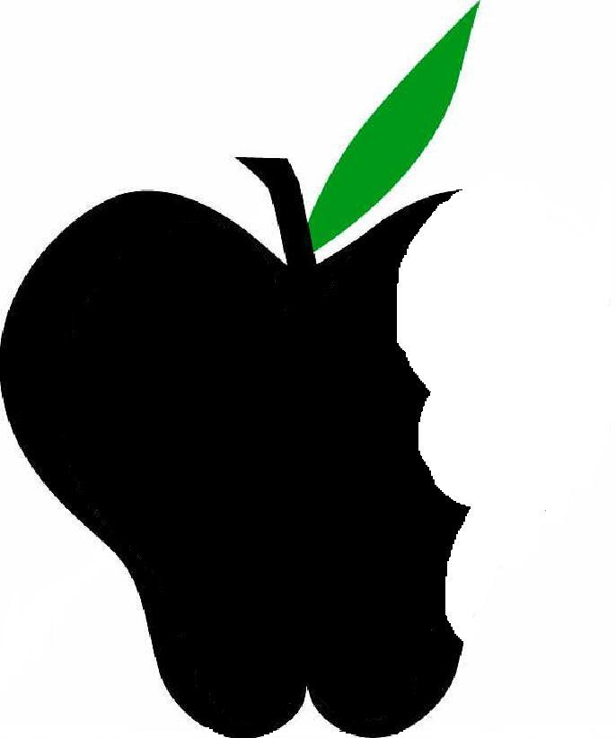
Beneficial Bites
Coffee…

How often do you remember waking up to the smell of hot coffee?

Coffee is actually made from small ground up seeds. If you place raw coffee seeds in the ground they will grow into a coffee tree. One tree will only produce 1-2 pounds of coffee per growing season.

Coffee is the second most traded commodity in the world second only to oil!

Health Benefits
Coffee has some pretty powerful health benefits which may include:
- Heart Disease and Stoke prevention
- Decreased risk for type II
Diabetes
- Certain Cancers
- Parkinson’s Disease in Men
Each year, 400 billion cups of coffee are consumed worldwide.

The history of this delicious beverage started with goats, yes goats, in the 9th century and still continues to be the most popular beverage consumed.
Beneficial Bites

Coffee…

How often do you remember waking up to the smell of hot coffee?

Coffee is actually made from small ground up seeds. If you place raw coffee seeds in the ground they will grow into a coffee tree. One tree will only produce 1-2 pounds of coffee per growing season.

Coffee is the second most traded commodity in the world second only to oil!

Health Benefits
Coffee has some pretty powerful health benefits which may include:
- Heart Disease and Stoke prevention
- Decreased risk for type II
Diabetes
- Certain Cancers
- Parkinson’s Disease in Men
Each year, 400 billion cups of coffee are consumed worldwide.

The history of this delicious beverage started with goats, yes goats, in the 9th century and still continues to be the most popular beverage consumed.
Beneficial Bites
Tea…

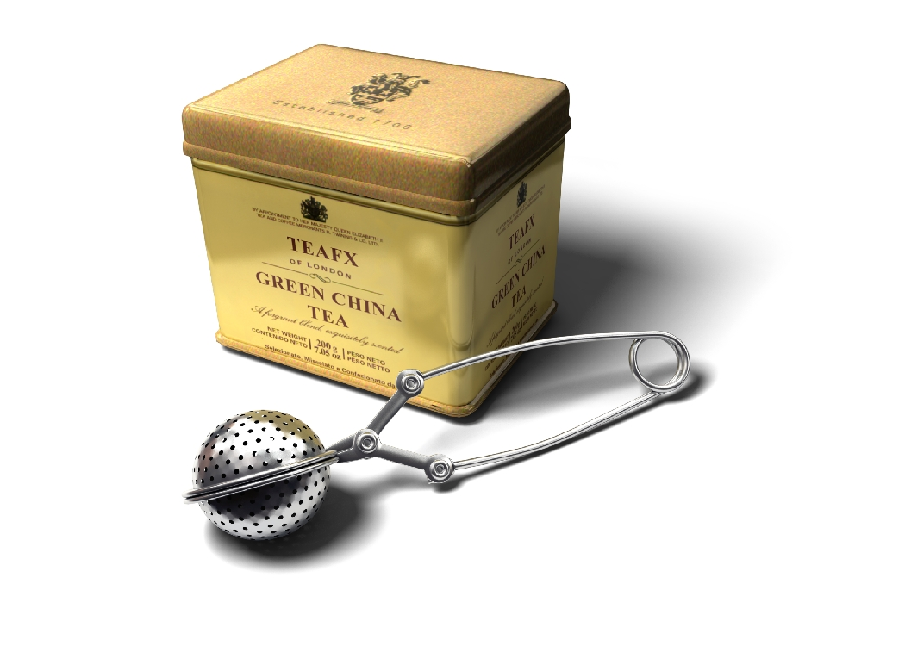
Tea is a name given to many brews but tea “purists” consider only green, black, white, oolong and pu-erh tea to be the real thing. With over 1500 “variateas” today and over 25 countries cultivating tea as a plantation crop, China remains one of the leading producers.

Health Benefits
Different teas may provide different health benefits. Some of these benefits include:
- Antioxidants
- Anticancer properties
- Lowering cholesterol
- Providing vitamins and minerals like B1, B2, B6, potassium, manganese, folic acid and calcium!

Tea, overall, has an estimated caffeine content of 20-80 mg per 8 oz cup while a cup of espresso can have up to 100-200 mg per 2 oz!

This document has been created by Heather Larson, UW-Stout Dietetic Intern, February 2013.

Tea…

Tea is a name given to many brews but tea “purists” consider only green, black, white, oolong and pu-erh tea to be the real thing. With over 1500 “variateas” today and over 25 countries cultivating tea as a plantation crop, China remains one of the leading producers.

Health Benefits
Different teas may provide different health benefits. Some of these benefits include:
- Antioxidants
- Anticancer properties
- Lowering cholesterol
- Providing vitamins and minerals like B1, B2, B6, potassium, manganese, folic acid and calcium!

Tea, overall, has an estimated caffeine content of 20-80 mg per 8 oz cup while a cup of espresso can have up to 100-200 mg per 2 oz!

This document has been created by Heather Larson, UW-Stout Dietetic Intern, February 2013.
Tea…

Tea is a name given to many brews but tea “purists” consider only green, black, white, oolong and pu-erh tea to be the real thing. With over 1500 “variateas” today and over 25 countries cultivating tea as a plantation crop, China remains one of the leading producers.

Health Benefits
Different teas may provide different health benefits. Some of these benefits include:
- Antioxidants
- Anticancer properties
- Lowering cholesterol
- Providing vitamins and minerals like B1, B2, B6, potassium, manganese, folic acid and calcium!

Tea, overall, has an estimated caffeine content of 20-80 mg per 8 oz cup while a cup of espresso can have up to 100-200 mg per 2 oz!

This document has been created by Heather Larson, UW-Stout Dietetic Intern, February 2013.

