
Beneficial Bites

Fun Facts

Health Benefits

- Coconut oil is considered a healthy saturated fat with medium-chained fatty acids.
- Some research has shown that coconut oil may be beneficial to increase the good cholesterol in the body, which can lower the risk of heart problems.
- Coconut oil provides quick energy for the body and helps you feel full longer which may aide in weight loss.
- Applying coconut oil to the skin twice daily can improve skin moisture in people with dry skin.


Created by Allison Freeman, MS, Dietetic Intern 2015
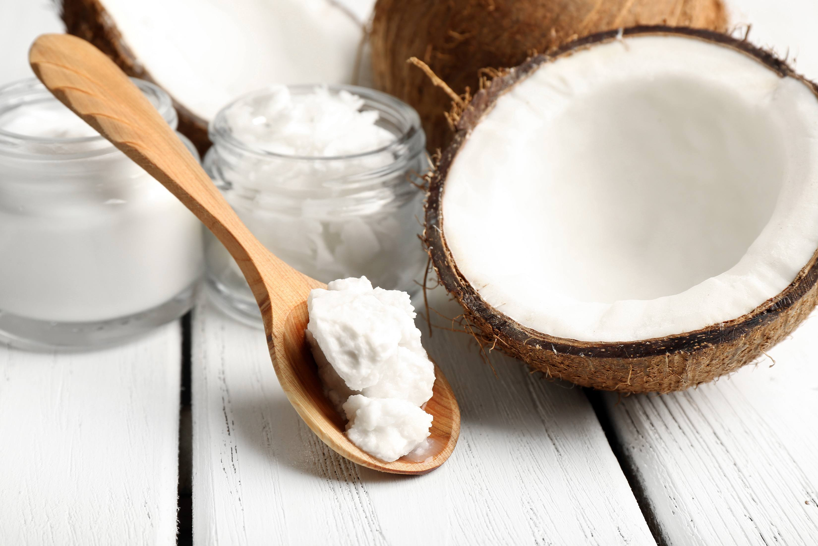

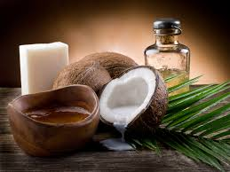

- Coconut is the largest seed in the world. A coconut palm tree can produce for 80 years.
- Select virgin, organic, cold-pressed coconut oil to get the best nutritional benefits.
- The sailors aboard Vasco de Gama’s ships gave the coconut its name. They called it “Coco”, named after a grimacing face or hobgoblin. When the “coco” came to England, the suffix of nut was added.
- The coconut industry is one of the most important industries in the Philippines.

Created by Li Cheng, MS, UW-Stout Dietetic Intern 2016

Try Coconut Oil in

- Roasted Veggies
- Breads
- Desserts
- Coffee
- Skin/Hair Care


