**Recipe for:****COCONUT OIL ROASTED VEGETABLES**

2 cups baby carrots or trimmed carrots 2 tablespoons fresh rosemary, chopped

1 cup Brussels sprouts, halved about 4 tablespoons coconut oil, melted or softened

1 cup green beans, trimmed juice of half of one lemon

1 cup broccoli florets salt and pepper, to taste

Preheat oven to 425F. Line a baking sheet, spray with cooking spray. Place vegetables on tray (choice of vegetables is mix-and-match and amounts approximate). Drizzle with 2 tablespoons melted coconut oil or if solid, sprinkle small pea-sized pieces haphazardly over the vegetables and toss vegetables to coat. Sprinkle with rosemary, salt, and pepper. Squeeze the juice from the lemon over the vegetables, and bake for about 25 minutes, flipping them over midway through cooking. Add 1 to 2 additional tablespoons coconut oil, or as necessary, if they look dry when flipping. Bake until vegetables are fork-tender and browned. Keep an eye on any cruciferous vegetables, especially broccoli, as it's prone to burning and pull it in advance of the other vegetables if necessary. Serve immediately.



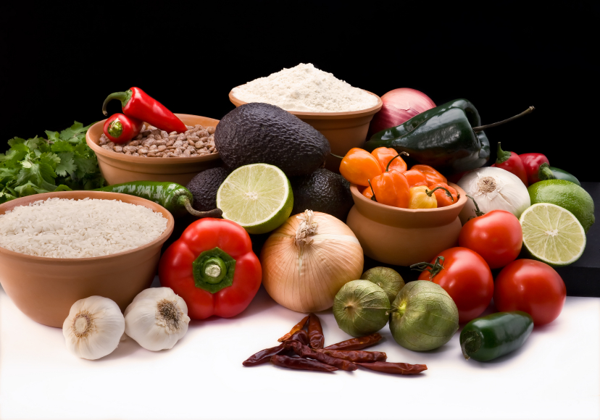

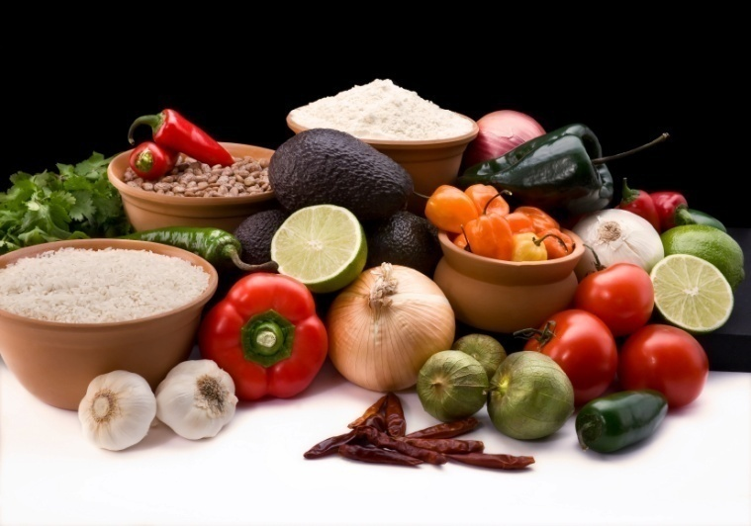

1/4 cup coconut oil 1 cup chopped onions

1 clove garlic, minced 3 cups vegetable broth

1 teaspoon curry powder 1/2 teaspoon salt

1/4 teaspoon ground coriander 1/4 teaspoon crushed red pepper flakes

1 (15 ounce) can 100% pure pumpkin

Heat the coconut oil in a deep pot over medium-high heat. Stir in the onions and garlic; cook until the onions are translucent, about 5 minutes. Mix in the vegetable broth, curry powder, salt, coriander, and red pepper flakes. Cook and stir until the mixture comes to a gentle boil, about 10 minutes. Cover, and boil 15 to 20 minutes more, stirring occasionally. Whisk in the pumpkin and coconut milk, and cook another 5 minutes.

Pour the soup into a blender, filling only half way and working in batches if necessary; process until smooth. Return to a pot, and reheat briefly over medium heat before serving.

**Recipe for:** **Coconut Curry Pumpkin Soup**



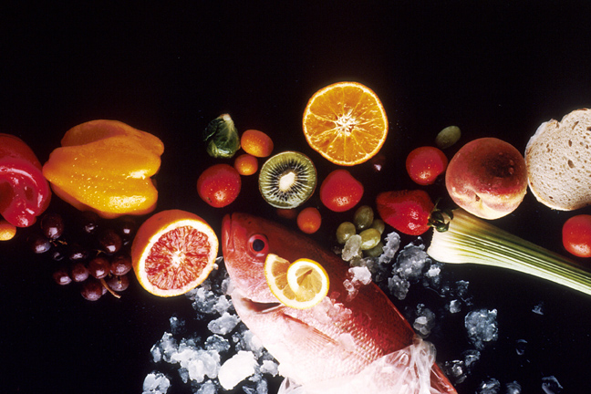

**Recipe for: No-Bake Chocolate Coconut Bark**

1/2 cup coconut oil

1/2 cup dark cocoa powder

¼ cup pure maple syrup

Pinch of salt

½ cup sliced almonds

½ cup finely shredded coconut

Combine coconut oil, cocoa powder, pure maple syrup and salt in a small bowl and mix well. Place parchment paper in 9x13 pan, sprinkle parchment with ½ sliced almonds. Pour chocolate mixture over almonds. Top with remaining almonds and coconut. Refrigerate until solid. Break bark into pieces and serve.





**Recipe for: Coconut Lime Rice**

1 cup basmati rice* 1 tablespoon coconut oil

1 teaspoon butter 1/4 cup flaked coconut

1 cup coconut milk 1 cup chicken broth

Salt, to taste 1 lime, zested and juiced

Ground black pepper, to taste

Rinse rice until the water runs clear; drain. Heat coconut oil and butter in a large skillet over medium-high heat. Cook and stir rice and coconut flakes for 3 to 4 minutes. Stir in the lime juice, then add the coconut milk, chicken broth, salt and lime zest. Bring to a low boil, then cover and reduce heat to low. Cook for 20 minutes. Remove from heat and keep covered for 5 minutes. Fluff with fork and season with pepper.

*Switch to brown rice to make a whole grain meal





**Recipe for: All-Natural No-Bake Cookies**

1 cup honey 1/2 cup coconut oil

1/2 cup cocoa powder 2 cups rolled oats

1 cup natural peanut butter 1 cup unsweetened flaked coconut

1 teaspoon vanilla extract

Combine honey, coconut oil, and cocoa powder in a small pot and bring to a boil; cook at a boil for 2 minutes and remove from heat. Stir oats, peanut butter, coconut, and vanilla extract into the hot honey mixture until the peanut butter melts and the mixture are smooth.

Drop mixture by spoonful onto waxed paper. Set aside to cool until firm, about 20 minutes.





**Recipe for: 3-INGREDIENT COCONUT OIL BISCUITS**

2 cups self-rising flour

1/4 cup coconut oil (solid, not melted)

3/4 cup coconut milk, or any milk

Preheat oven to 425 degrees.

Add self-rising flour and coconut oil to a mixing bowl, and use a pastry cutter or forks to cut the coconut oil into the flour until the mixture is like fine crumbs. Stir in the milk until mixture forms a soft dough and no longer sticks to the sides of the bowl. Knead the mixture until combined, but be careful not to over-knead.

Turn the dough out onto a cutting board that has been lightly dusted with flour. Gently roll the dough out until it reaches a 1/2-inch thickness. Use a biscuit cutter (mine was a 2-inch circle) to cut out the biscuits, and transfer to a baking sheet.

Bake for 10 minutes, or until the biscuits have risen and ever so slightly begin to brown on top. Remove and serve immediately.



