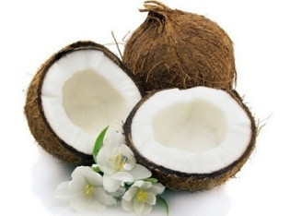



Beneficial Bites

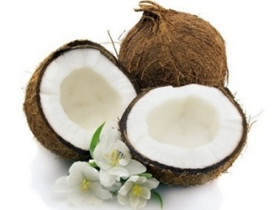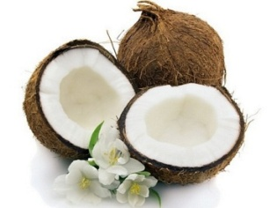

**History**

Coconut oil is an edible oil extracted from the kernel or meat of mature coconuts harvested from the coconut palm. In many tropical countries it has been a diet staple for some 4000 years. After World War II coconut oil was sold as margarine in England and coconut butter in the United States. In its natural unaltered form this staple has been used as medicine and food by diverse groups around the globe.

**Benefits**

Coconut oil can be used in various ways at home, such as cooking, baking, and moisturizing skin and hair. Coconut oil is one of the richest sources of saturated fat. Almost 90% of the fatty acid in coconut oil is saturated. The form of saturated fat in coconut oil is different from the one found in cheese or steak, which makes it a healthier fat with unique health benefits including quick energy and antioxidants.

**History**

Coconut oil is an edible oil extracted from the kernel or meat of mature coconuts harvested from the coconut palm. In many tropical countries it has been a diet staple for some 4000 years. After World War II coconut oil was sold as margarine in England and coconut butter in the United States. In its natural unaltered form this staple has been used as medicine and food by diverse groups around the globe.

**Benefits**

Coconut oil can be used in various ways at home, such as cooking, baking, and moisturizing skin and hair. Coconut oil is one of the richest sources of saturated fat. Almost 90% of the fatty acid in coconut oil is saturated. The form of saturated fat in coconut oil is different from the one found in cheese or steak, which makes it a healthier fat with unique health benefits including quick energy and antioxidants.

**History**

Coconut oil is an edible oil extracted from the kernel or meat of mature coconuts harvested from the coconut palm. In many tropical countries it has been a diet staple for some 4000 years. After World War II coconut oil was sold as margarine in England and coconut butter in the United States. In its natural unaltered form this staple has been used as medicine and food by diverse groups around the globe.

**Benefits**

Coconut oil can be used in various ways at home, such as cooking, baking, and moisturizing skin and hair. Coconut oil is one of the richest sources of saturated fat. Almost 90% of the fatty acid in coconut oil is saturated. The form of saturated fat in coconut oil is different from the one found in cheese or steak, which makes it a healthier fat with unique health benefits including quick energy and antioxidants.



Beneficial Bites



Beneficial Bites

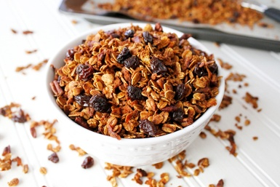

**Fun Facts**

Coconut is the largest seed in the world.

Coconuts are a prehistoric plant that scientists believe came from the South Pacific around what is now New Guinea.

The sailors aboard Vasco de Gama’s ships gave the coconut its name.  They called it “Coco”, named after a grimacing face or hobgoblin. When the “coco” came to England, the suffix of nut was added.

The coconut industry is one of the most important industries in the Philippines.

Created by Li Cheng, MS, UW-Stout Dietetic Intern, 2016

**Fun Facts**

Coconut is the largest seed in the world.

Coconuts are a prehistoric plant that scientists believe came from the South Pacific around what is now New Guinea.

The sailors aboard Vasco de Gama’s ships gave the coconut its name.  They called it “Coco”, named after a grimacing face or hobgoblin. When the “coco” came to England, the suffix of nut was added.

The coconut industry is one of the most important industries in the Philippines.

Created by Li Cheng, MS, UW-Stout Dietetic Intern, 2016

**Fun Facts**

Coconut is the largest seed in the world.

Coconuts are a prehistoric plant that scientists believe came from the South Pacific around what is now New Guinea.

The sailors aboard Vasco de Gama’s ships gave the coconut its name.  They called it “Coco”, named after a grimacing face or hobgoblin. When the “coco” came to England, the suffix of nut was added.

The coconut industry is one of the most important industries in the Philippines.

Created by Li Cheng, MS, UW-Stout Dietetic Intern, 2016

**Check Out the February Menu**

**for These “Coconut Oil” Foods**

* Chocolate Coconut Bars
* Oatmeal Cherry Coconut Cookies
* Carrot Cake Coconut Granola

**Check Out the February Menu**

**for These “Coconut Oil” Foods**

* Chocolate Coconut Bars
* Oatmeal Cherry Coconut Cookies
* Carrot Cake Coconut Granola

**Check Out the February Menu**

**for These “Coconut Oil” Foods**

* Chocolate Coconut Bars
* Oatmeal Cherry Coconut Cookies
* Carrot Cake Coconut Granola



Beneficial Bites



Beneficial Bites



Beneficial Bites