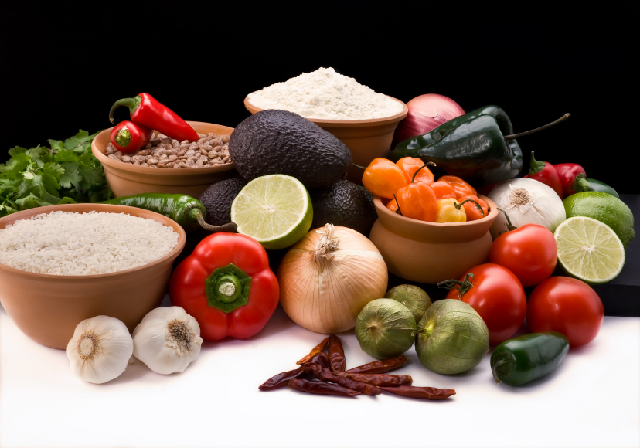
Recipe for: Cinnamon Pork Tenderloin
3 Tablespoons soy sauce
3 Tablespoons sherry or chicken broth
1 Tablespoon brown sugar
1 ½ teaspoons honey
1 teaspoon ground cinnamon
1 garlic clove, minced
2 pork tenderloins (about ¾ pound each)

In large, resealable plastic bag, combine first six ingredients. Add pork, seal bag and turn to coat. Refrigerate pork in bag 4-6 hours. Drain and discard marinade. Grill pork, covered, over medium heat for 15-20 minutes or until meat thermometer reads 160°F, turning occasionally. Let stand 5 minutes before slicing.

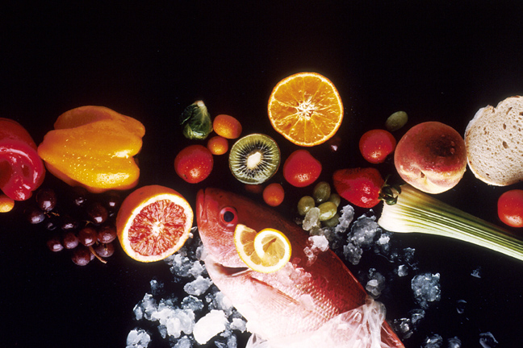
Recipe for: Spice Cookies w/Pumpkin Dip
1 ½ cups butter, softened2 cups sugar
2 eggs½ cup molasses
4 cups all-purpose flour4 teaspoons baking soda
2 teaspoons ground cinnamon1 teaspoon EACH ground ginger & cloves
1 teaspoon salt
In bowl, cream butter and sugar. Add eggs, one at a time, beating well after each addition. Add molasses, mix well. Combine flour, soda, cinnamon, ginger, cloves and salt. Add to creamed mixture and mix well. Chill overnight or several hours. Shape into ½-inch balls, roll in sugar and place 2 inches apart on ungreased baking sheets. Bake at 375°F for 6 minutes or until edges begin to brown. Cool on wire rack.
For Pumpkin Dip: Beat 8 oz reduced fat cream cheese in bowl until smooth. Add 2 cups pumpkin pie filling and beat well. Add 2 cups powdered sugar, 1 teaspoon ground cinnamon and ½ teaspoon ground ginger and again beat until smooth. Serve with cookies!

Recipe for: Cinnamon-Apple Pork Chops
4 boneless pork loin chops
3 Tablespoons brown sugar
1 teaspoon ground cinnamon
½ teaspoon ground nutmeg
¼ teaspoon salt
4 medium tart apples, thinly sliced
2 Tablespoons chopped pecans
1 Tablespoon butter

In large skillet treated with food release spray, over medium heat, cook pork chops for 4-5 minutes on each side or until meat thermometer reads 160°F. Meanwhile in small bowl, combine brown sugar, cinnamon, nutmeg and salt. Remove chops and keep warm. Add apples, pecans and brown sugar mixture to the pan. Cook and stir until apples are tender. Serve with chops.

Recipe for: Cinnamon Carrots
1 – 16 oz package frozen sliced carrots
¼ cup honey
1 tablespoon butter
½ - 1 teaspoon ground cinnamon

Cook carrots until preferred tenderness is reached. Meanwhile, combine honey, butter and cinnamon in small microwave bowl and heat until butter melts. Stir to blend. Drain carrots, place in serving bowl and drizzle with honey mixtures. Serve immediately.

