Cinnamon
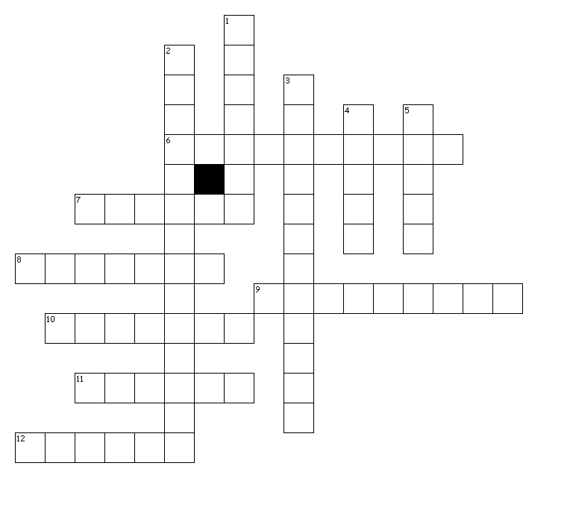
Across

6. In Mexico, cinnamon is commonly added to this sweet treat.

7. Cinnamon was as valuable as gold silver and was even used as _____.

8. After salt and pepper this form of cinnamon is the most common spice found in kitchens

9. In Medieval times cinnamon was used as _____ for various ailments.

10. The most expensive type of cinnamon named after an island where it is grown.

11. This famous and most read book in the world mentions cinnamon.

12. Cinnamon in this form is often used in crafts as well as cooking & baking.

Down

1. Cassia cinnamon is the less expensive variety and has a much stronger ___.

2. Sugar cookie that is rolled in cinnamon-sugar before baking.

3. Cinnamon may help lower ____ levels.

4. Cinnamon comes from the ____ of a tropical evergreen tree.

5. Cinnamon was once used in ____ preservation.

