**Let’s Chive-Fun Facts about Chives**

#### What’s all the CHIVE about?

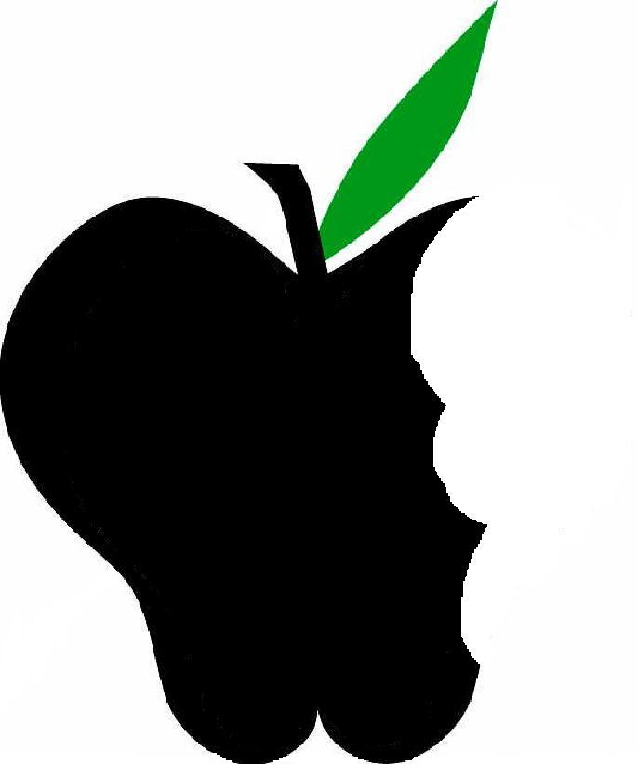

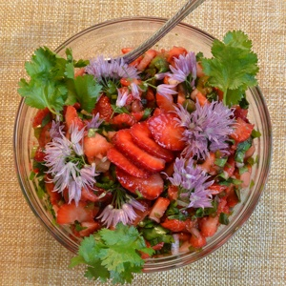

* It was thought that hanging bunches of chives around a house could also ward off evil.
* Medicinally, **chives**have been used in traditional Chinese medicine to promote sweating and male fertility.
* The Romans seem to have believed that chives could relieve a sore throat and sunburns.
* Romanian Gypsies use chives for fortunetelling.
* It is said that the Siberians treasured chives and used them as a gift to god. They were given as they believed that chives were to greatest aphrodisiac known to man.

The medicinal properties of chives are as varied as their uses in the kitchen. Here are a few of the proposed health benefits:

* Chives surprisingly contain multiple vitamins and minerals including: Vitamin K, A and C, calcium, iron, magnesium, phosphorus, potassium, and sodium.
* Chives are known to be a mild anti-inflammatory.
* They have some antibiotic properties.
* Chives may ease stomach distress.
* They may protect against heart disease and stroke.
* Scientific research shows that chives stimulate the body's digestion of fat.
* Chives may increase appetite.

Did you know….That the whole Chive plant is edible even the flower! Try adding it do a dish to make it decorative.

**Chive up your life by adding chives to:**

Potatoes

Soups

Pastas

Salads

Breads

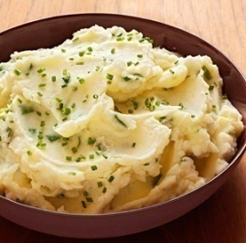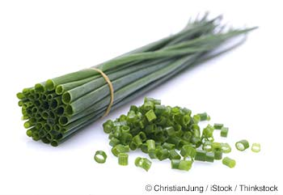

Created by: Ellen Ellingsworth, MS

UW-Stout Dietetic intern

