**Sour Cream and Chive Roll**

1 cup Sour Cream 1 teaspoon salt

½ cup White Sugar ½ cup Butter, melted

2 Eggs 2 (.25oz) packages active dry yeast

4 cups all-purpose flour ½ cup chopped chives

½ cup warm water

In a small saucepan, heat sour cream until very hot. Add salt, sugar, and melted butter. Cool until lukewarm. In a large bowl, dissolve yeast in warm water. Mix in sour cream mixture, eggs, flour, and chives. Cover, and refrigerate overnight. Preheat oven to 375 degrees F (190 degrees C). Grease baking sheets or line them with parchment paper. Divide dough into 4 parts; shape each piece into a ball. Cover dough rounds with plastic wrap when not working with them. Roll a ball into a 10-inch circle. Let dough rest while you roll out another circle. Cut first circle into 12 thin pie-shaped pieces. Starting at the wide end, roll up each triangle, ending with the point. Curl the edges in toward the point. Place point-side down on prepared baking sheets. Repeat with remaining dough. Allow crescent rolls to rise until doubled in size, about 30 minutes. Bake in preheated oven until golden brown, 12 to 15 minutes.



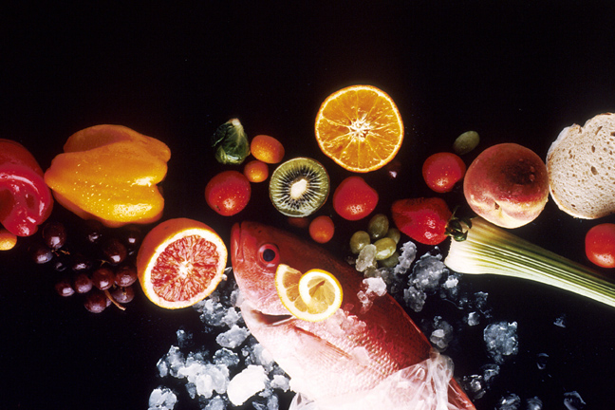

**Blue Cheese, Bacon and Chive Stuffed Pork Chops**

2 boneless pork chops garlic and salt to taste

4 ounce crumbled blue cheese ground pepper to taste

2 slices bacon-cooked and crumbled Chopped parsley

2 tablespoon chopped fresh chives

Preheat the oven to 325 degrees. Grease a shallow baking dish. In a small bowl, mix together the blue cheese, bacon and chives. Divide into halves, and pack each half into a loose ball. Place each one into a pocket of a butterflied pork chop, close, and secure with toothpicks. Season each chop with garlic salt and pepper. Keep in mind that the blue cheese will be salty. Place in the prepared baking dish. Bake for 20 minutes in the preheated oven, or it may take longer if your chops are thicker. Cook until the stuffing is hot, and chops are to your desired degree of doneness. Garnish with fresh parsley and serve.

.





**Sour Cream, Cheddar and Chive Potato Waffles**

Cooking spray 1 teaspoon baking powder

1 ¾ cups fat free milk 1 package potato pancake mix

1 large egg 8 oz sour cream

1/2 cup shredded cheddar cheese 1 cup chopped chives

Coat a waffle iron with cooking spray, and preheat. Combine baking powder and potato pancake mix in a large bowl. Place milk, sour cream, and egg in a medium bowl; stir well with a whisk. Add milk mixture to potato pancake mixture, stirring until smooth. Fold in cheese and chives. Spoon about 1/2 cup batter onto hot waffle iron, spread batter to edges. Cook 3 to 5 minutes or until done; repeat procedure with remaining batter.





**Chive Cucumber Salad**

2 tablespoons chopped dill 2 tablespoon chopped chives

1 (8oz) container sour cream 1 tablespoon fresh lemon juice

1 large cucumber sliced

Mix the dill, chives, and sour cream together in a bowl. Stir the lemon juice into the sour cream mixture; allow to sit at room temperature for 30 minutes. Add the sour cream mixture to the cucumbers and stir gently until coated. Serve immediately.





**Zucchini Chive Dip**

1 (8oz) package cream cheese, softened 3 tablespoons milk

1 cup zucchini, shredded 3 tablespoon chopped chives

1/8 teaspoon salt

In a medium bowl, mix cream cheese, and milk until well blended. Mix in shredded zucchini, chives and salt. Chill in the refrigerator approximately 1 hour before serving. Serve with crackers or pretzels.





**Strawberry Lime Salsa with Chive Blossoms**

1 pint strawberries 1 bunch cilantro

4 scallions, sliced 1 jalapeno (seeds removed and chopped)

1 lime (juiced) 4-6 chive blossoms

¼ teaspoon salt

Squeeze juice of one lime into a bowl. Thinly slice scallions. Chop jalapeno, cilantro and strawberries. Add them to the bowl with the lime juice. Salt to taste. Let the salsa rest for 10 to 20 minutes so the flavors mingle. Tear chive blossoms apart carefully for garnish.



