

**Beneficial Bites**

Dark Sweet Cherries

Health Benefits:

* Contains approximately 4,873 total antioxidants
* Contains anti-inflammatory properties
* Inhibits cancer
* 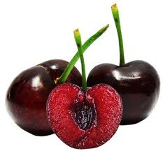Good source of vitamins and minerals
* Promotes bone health

Interesting Facts:

* Cherries are drupes, or stone fruit, which make them a distant cousin to peaches, plums, apricots, and almonds.
* Sweet cherries were brought to America in 1629 with English Colonists
* Harvest timing for cherries is based on latitude, altitude, and variety.
* On average, there are about 44 cherries in one pound.
* Cherries are harvested 60-80 days after bloom.
* Americans consume an average of one and a half pounds of cherries each year.



Beneficial BitesBeneficial Bites

Dark Sweet Cherries

Health Benefits:

* Contains approximately 4,873 total antioxidants
* Contains anti-inflammatory properties
* Inhibits cancer
* Good source of vitamins and minerals
* Promotes bone health

Interesting Facts:

* Cherries are drupes, or stone fruit, which make them a distant cousin to peaches, plums, apricots, and almonds.
* Sweet cherries were brought to America in 1629 with English Colonists
* Harvest timing for cherries is based on latitude, altitude, and variety.
* On average, there are about 44 cherries in one pound.
* Cherries are harvested 60-80 days after bloom.
* Americans consume an average of one and a half pounds of cherries each year.





Beneficial Bites

Dark Sweet Cherries

Health Benefits:

* Contains approximately 4,873 total antioxidants
* Contains anti-inflammatory properties
* Inhibits cancer
* Good source of vitamins and minerals
* Promotes bone health

Interesting Facts:

* Cherries are drupes, or stone fruit, which make them a distant cousin to peaches, plums, apricots, and almonds.
* Sweet cherries were brought to America in 1629 with English Colonists
* Harvest timing for cherries is based on latitude, altitude, and variety.
* On average, there are about 44 cherries in one pound.
* Cherries are harvested 60-80 days after bloom.
* Americans consume an average of one and a half pounds of cherries each year.



Check out the February menu for these “Dark Sweet Cherry” foods

Featured Recipes:

* Apple Cherry Crisp
* Cherry Glazed Pork Tenderloin
* Cherry Oatmeal Cookies
* Cherry Cream Cheese Bars

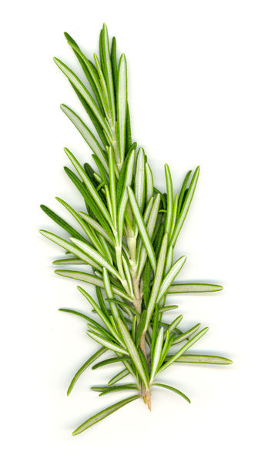

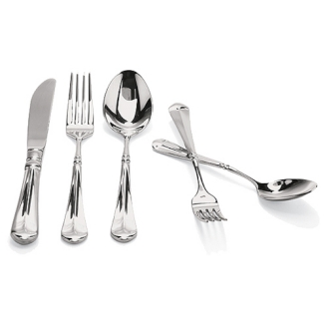

Created by Melissa Panchyshyn, MS

UW-Stout Dietetic Intern

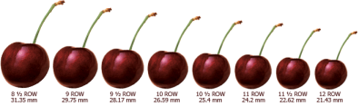

Check out the February menu for these “Dark Sweet Cherry” foods

Featured Recipes:

* Apple Cherry Crisp
* Cherry Glazed Pork Tenderloin
* Cherry Oatmeal Cookies
* Cherry Cream Cheese Bars



Created by Melissa Panchyshyn, MS

UW-Stout Dietetic Intern



Check out the February menu for these “Dark Sweet Cherry” foods

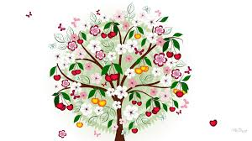

Featured Recipes:

* Apple Cherry Crisp
* Cherry Glazed Pork Tenderloin
* Cherry Oatmeal Cookies
* Cherry Cream Cheese Bars



Created by Melissa Panchyshyn, MS

UW-Stout Dietetic Intern

