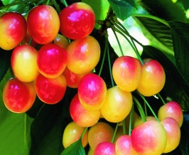
Cherries are members of the Rosaceae or Rose family. They are distant cousins to peaches, plums, apricots and almonds.
Sweet Cherries
- Often heart-shaped
- Usually larger than sour/tart cherries
- Range in color from golden red to purplish-black
- Examples include
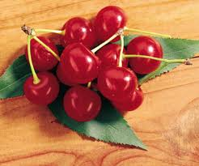
Bing, Rainier, Lambert, Tartarian, & Royal Ann

Sour Cherries
- Usually too tart to eat raw
- Most are bright to dark red in color
- Globular in shape and softer flesh
- Examples include Morella, Montmorency, & Early Richmond
Cherry Fun Facts
In general, the darker the cherry the sweeter it’s flavor…of course, the yellow cherry varieties would be the exception.
The main Sweet Cherry producing states are Washington, California, Oregon, and Michigan.
The main Sour Cherry producing states are Michigan, Washington, Utah, New York, Pennsylvania and Wisconsin!
Those famous Cherry Blossoms displayed in Washington DC are ornamental trees and do not actually bear fruit.
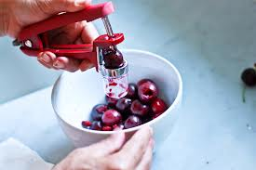
It takes about 250 sour cherries to make a cherry pie so you may want to invest in a cherry pitter.
Cherries Are Super!
- Like most fruit, cherries are a good source of fiber, both soluble and insoluble!
- Cherries are rich in vitamin C and vitamin A. They also provide a good dose of potassium!
- Cherries are loaded with antioxidants, making them a Superfood by any standard!

Not just for pie…
…add to cereal & yogurt
…use in sauces for chicken & pork
…toss into salads and sandwiches
…add to pancake & waffle batters
…add to lemonade and smoothies
…freeze them for later use.

