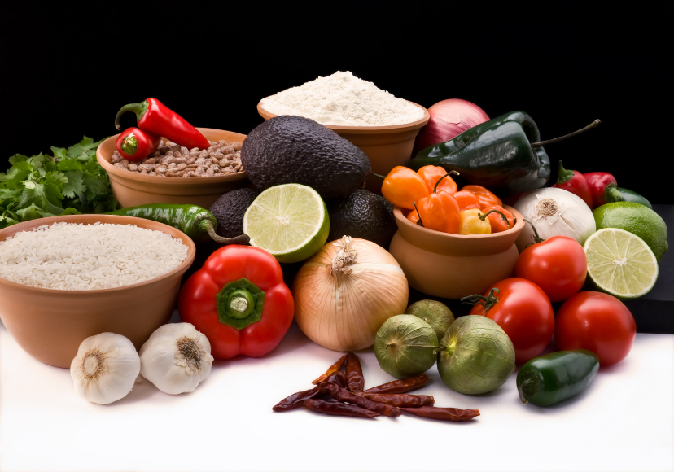
Recipe for: Honey Soaked Quinoa Salad
With Cherries and Cashews
1 cup cooked, cooled quinoa
¼ cup coarsely chopped cashews
¼ cup sliced dried apricots
½ cup fresh pitted, halved cherries
¼ cup thinly sliced red onion
2 cups romaine or favorite lettuce
½ cup Honey Vinaigrette

Fluff quinoa with fork. Toss with cashews, apricots, cherries and onion. Add lettuce and drizzle with ¼ cup vinaigrette. Season with fresh ground salt & pepper. Serve with remaining vinaigrette.

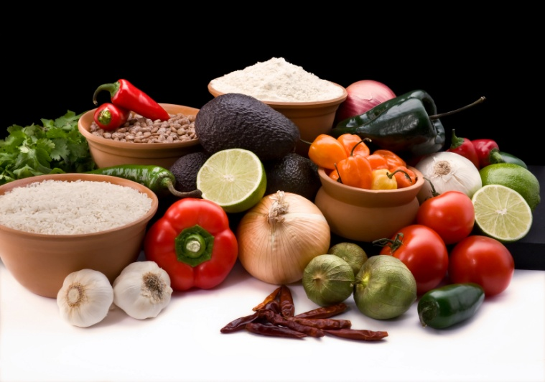
Honey Vinaigrette
1 Tbsp grated ginger
2 Tbsp honey
1 Tbsp white wine vinegar
1 Tbsp lime juice
½ tsp minced garlic
2 Tbsp olive oil
Dash salt & pepper
Whisk together all ingredients. Makes ½ cup.

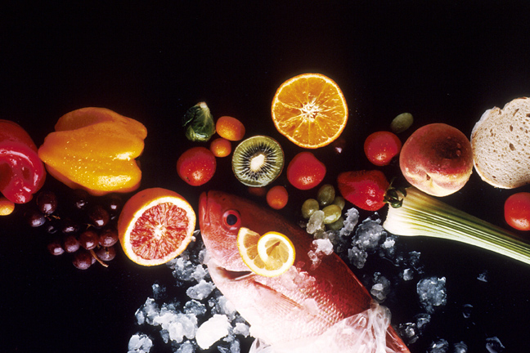
Recipe for: Cherry Chicken Salad
2 cups cubed cooked chicken breast
1 cup fresh sweet cherries (can substitute ½ cup dried cherries)
½ cup chopped celery
¼ cup chopped onion
½ cup chopped tart apple (toss with small amount of acidic juice to prevent browning)
¼ cup chopped almonds
½ cup low fat mayonnaise
1 Tbsp lemon juice
1 tsp soy sauce
¼ tsp ground ginger

In large bowl, combine chicken, cherries, celery, onion, apple and almonds. In small bowl, whisk together mayonnaise, lemon juice, soy sauce and ginger. Add to chicken mixture and gently combine to even coat. Serve on bed of lettuce or croissant roll.

Recipe for: Cherry Oatmeal Muffins

1 cup old fashioned rolled oats¾ cup all-purpose flour
¾ cup whole wheat flour1/3 cup wheat germ
1/3 cup sugar1 tsp baking powder
½ tsp baking soda½ tsp salt
1 1/3 cups buttermilk3 Tbsp oil
1 large egg1 Tbsp grated orange zest
¾ cup dried cherries

Preheat oven to 375°. Line 12 muffin cups with paper liners. Toast oats and wheat germ in jelly roll pan until golden brown and crisp, stirring often. Allow to cool then combine in large bowl with other dry ingredients. In small bowl combine milk, oil, egg and orange zest. Add to dry ingredients, stirring just until dry ingredients are moistened. Fold in cherries. Spoon into muffin cups; sprinkle top of each muffin with an additional pinch of sugar.Bake until golden brown and toothpick comes out clean, about 30 minutes. Remove from pan to cool.

Recipe for: Chocolate Bing-A-Lings

24 Bing cherries with stem
1 ½ tsp vanilla extract
8 oz semisweet or dark chocolate
White sugar

Pour sugar into shallow dish. Drop two drops of vanilla at a time into the dish at 24 separate places to form lumps of vanilla-sugar. Set aside and allow lumps to harden. Meanwhile, using sanitized paperclip, cherry pitter or some other creative method, carefully remove pit while keeping stem intact. Insert one hardened vanilla-sugar clump into each cherry where pit was.

In small bowl, melt chocolate in microwave, stirring every 30 minutes until smooth melted and smooth. Holding stem, dip each cherry in chocolate leaving very top uncovered. Place on waxed paper and refrigerate overnight to allow sugar lumps to dissolve.
Recipe for: Cherry Burgers
1 pound lean ground beef
1 cup pitted sweet cherries, finely chopped
¼ cup chopped onions
2 Tbsp chopped fresh basil (1 T dried)
1 small garlic clove, minced
1 Tbsp Worcestershire Sauce
¼ Tsp salt and pepper

Combine all ingredients in large bowl. Form into 4 hamburger patties. Grill over medium heat until burgers are cooked through about 15-20 minutes, turning once halfway through grilling process. Serve immediately on whole wheat buns.

For a little extra Cherry Zip…top burger with Hot Cherry Orange Relish.

Recipe for: Apple Cherry Pork Chop

2 boneless pork loin chops (4-5 oz each)½ tsp dried thyme
¼ tsp each salt and pepper1 Tbsp olive oil
2/3 cup apple juice1 small red apple, sliced
¼ cup dried cherries2 Tbsp chopped onion
1 tsp cornstarch

Sprinkle pork chops with thyme, salt and pepper. Heat olive oil in large skillet and cook and brown pork over medium heat about 4-5 minutes on each side. Remove from pan and let stand about 5 minutes. In same skillet, combine apples, cherries and onion. In small bowl, combine apple juice and cornstarch. Add to skillet and bring all ingredients to boil, stirring constantly. Cook 1-2 minutes until thickened. Reduce heat to simmer. Add pork chops skillet and cook until pork juices run clear.

Hot Cherry Orange Relish
1 cup chopped sweet cherries
½ cup chopped unpeeled orange
½ cup chopped sweet onion
1 pickled jalapeno pepper, chopped

Combine all and season with salt and pepper.

