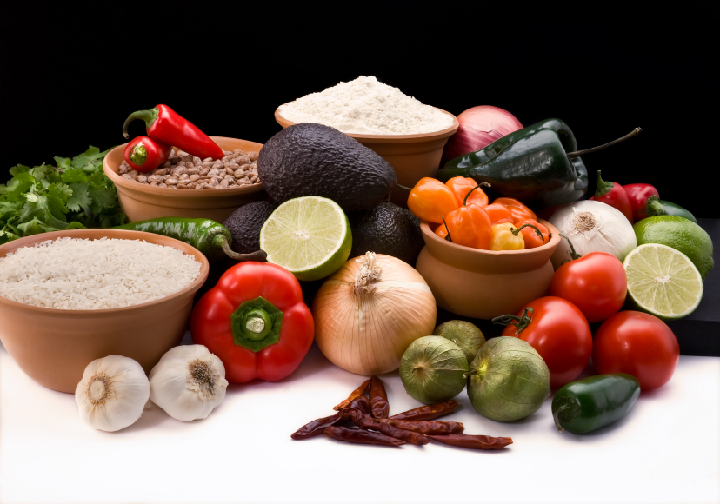
Recipe for: Kale Chips
1 bunch kale
1 tablespoon extra-virgin olive oil, divided
1 tablespoon sherry vinegar (or preferred vinegar)
1 pinch sea salt, to taste

Preheat an oven to 300 F. Cut away inner ribs from each kale leaf and discard; tear the leaves into pieces about the size of a small potato chip. Wash torn kale pieces and dry well with paper towels. Put the kale pieces into a large resealable bag. Add the olive oil; seal and squeeze the bag so the oil gets distributed evenly on the kale pieces. Sprinkle the vinegar over the kale leaves, reseal the bag, and shake to spread the vinegar evenly over the leaves. Spread the leaves evenly onto a baking sheet. Roast in the preheated oven until mostly crisp, about 35 minutes. Season with salt and serve.

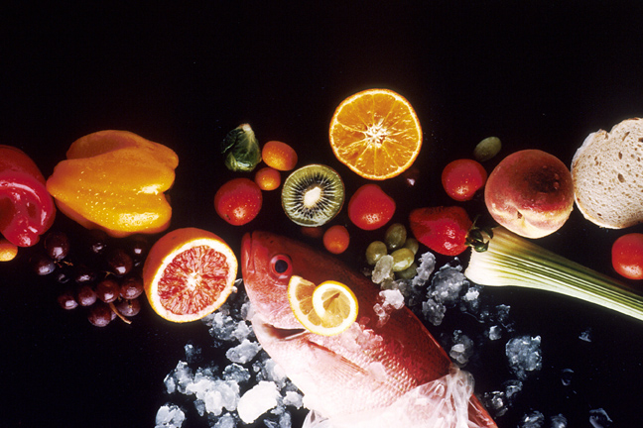
Recipe for: Sweet and Spicy Swiss Chard

1 tablespoon olive oil
1 bunch Swiss chard - leaves and stems separated and chopped
1/3 cup chopped yellow onion
1 ½ tablespoons ground ginger
1 teaspoon salt
1 teaspoon pepper
1 tablespoon maple syrup

Heat the oil in a large skillet over medium heat. Cook the chopped chard stems and onion in the hot oil until they begin to soften. Stir in ginger, salt, and pepper. Add the chopped chard leaves to the skillet; reduce heat to low. Continue cooking until the leaves have wilted, about 2 minutes. Drizzle the maple syrup over the mixture; stir to coat evenly. Serve and enjoy.
Recipe for: Savory Greens with Kidney Beans
1 bunch mustard greens, chopped
1 tablespoon butter
3/4 cup yellow onion, chopped
1 (15 ounce) can kidney beans, drained and rinsed
1 (15 ounce) can tomato sauce
2 teaspoons curry powder
1 tablespoon ground ginger
1 pinch crushed red pepper
1/2 cup half and half (or evaporated milk)

Bring a large pot of lightly salted water to a boil. Place greens in the pot, cover, and cook 7 minutes, or just until tender. Drain, and rinse under cold water. Heat the butter in a skillet over medium-high heat, and cook the onion until lightly brown. Mix in greens, kidney beans, tomato sauce, ginger, crushed red pepper, and curry powder. Stir in the half and half, and continue cooking until heated through. Serve alone or over rice.
Recipe for: Watercress Pesto

1/2 clove garlic
1/3 cup walnuts
3 ounces watercress, rinsed and dried
1 cup freshly grated Parmesan cheese
2 tablespoons mayonnaise

Place the garlic, walnuts, watercress, Parmesan cheese, and mayonnaise into a food processor or blender. Blend until a finely chopped paste has formed. Serve on top of pastas or salads. Makes about 1 cup.

