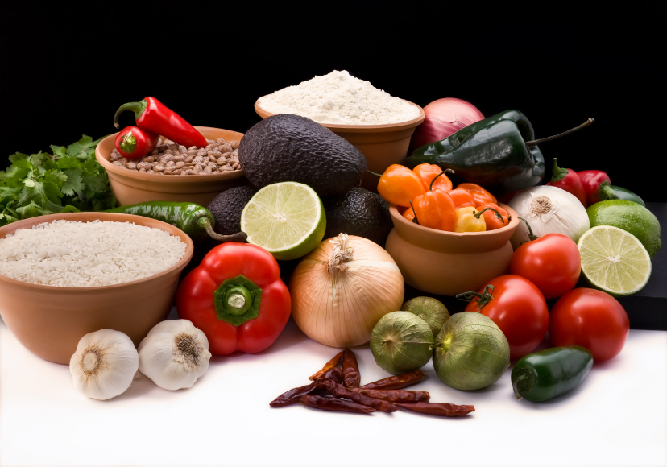
Recipe for: Zesty Radish Dip

4 cloves garlic, peeled
6 radishes, quartered
1 tablespoon lemon juice
1 tablespoon chopped fresh dill or 1 teaspoon dried
2 (8 ounce) packages cream cheese, softened

Place garlic in the container of a food processor, and pulse until finely minced.
Add radishes, and mince. Add cream cheese, and mix until well blended. Transfer to a serving dish, and chill until serving. Serve with crackers, chips, or vegetable strips. Makes about 2 cups.

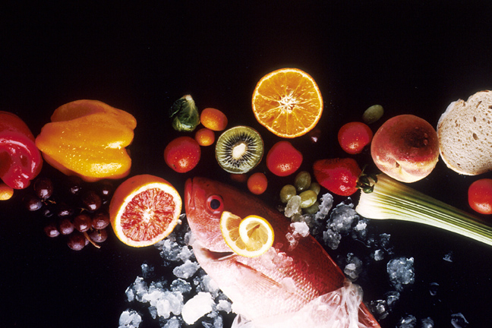
Recipe for: Tangy Turnip Salad
4 turnips, peeled and chopped
1 bunch green onions, chopped (about ½ cup)
2 Granny Smith apples - peeled, cored and chopped
4 slices canned pineapple, chopped
1/2 cup white sugar
1/4 cup vegetable oil
1 teaspoon salt
1/4 teaspoon ground black pepper

Bring a large pot of salted water to a boil. Add turnips and cook until tender but still firm, about 15 minutes. Drain, and cool. In a large bowl, combine the turnips, green onions, apples, pineapple and sugar. Stir to evenly coat with the sugar. Whisk together the oil, salt and pepper. Pour dressing over fruit and vegetables. Toss and refrigerate overnight.

Recipe for: Irish Rutabaga Pudding

1 pound rutabaga, peeled and cut into 1 1/2 inch cubes
3 tablespoons fine breadcrumbs
1/2 cup milk
2 tablespoon butter
1/4 cup white sugar
1 teaspoon salt
1 pinch ground nutmeg
1 large egg, well beaten

Clean, peel and cube the rutabaga, and cook in boiling water until tender, then drain. Mash thoroughly in a large bowl. Mix in all other ingredients. Put into a 2-qt casserole dish and bake at 350F for 1 hour. A pinch of cinnamon or ginger may also be added if desired.

Recipe for: Bowties and Broccoli

1 pound dry bow tie pasta
4 cups broccoli florets
1/4 cup olive oil
4 cloves garlic, sliced
1 cup grated Romano cheese (or Parmesean)

Bring a large pot of lightly salted water to a boil. Add pasta and cook until firm but not hard. Drain and save 1/4 cup pasta water. Place broccoli in a pot fitted with a steamer basket over boiling water. Steam until tender. Heat the oil in a skillet over medium heat. Stir in garlic, and cook until golden brown. In a bowl, toss together the pasta, pasta water, broccoli, garlic, remaining oil, and cheese. Season with salt and pepper.

