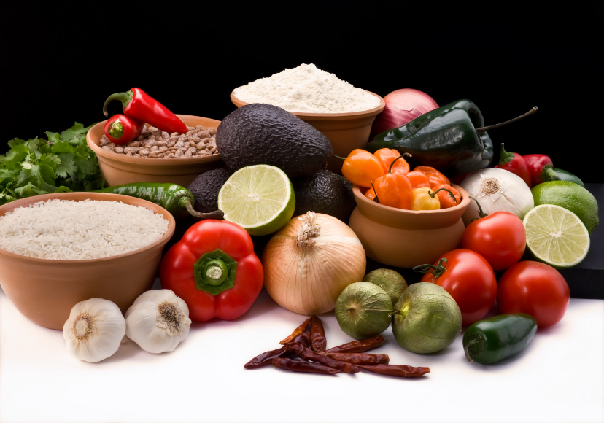
Recipe for: Roasted Garlic Cauliflower
2 tablespoons minced garlic
3 tablespoons olive oil
1 large head cauliflower, separated into florets
1/3 cup grated Parmesan cheese
salt and black pepper to taste
1 tablespoon chopped fresh parsley

Preheat the oven to 450 F. Grease a large casserole dish. Place the olive oil and garlic in a large resealable bag. Add cauliflower, and shake to mix. Pour into the prepared casserole dish, and season with salt and pepper to taste. Bake for 25 minutes, stirring halfway through. Top with Parmesan cheese and parsley, and broil for 3 to 5 minutes, until golden brown.

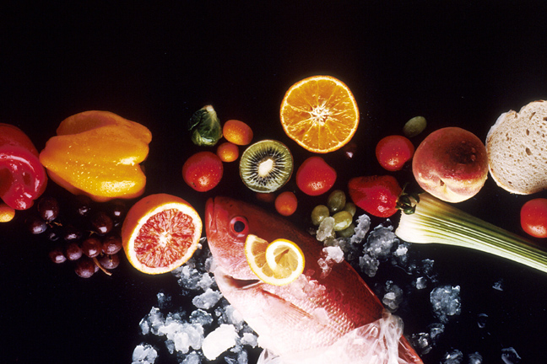
Recipe for: Cheddar Broccoli Pie
3/4 cup baking mix
3 eggs
1 1/3 cups milk
2 (10 ounce) packages chopped frozen broccoli, thawed
2/3 cup chopped onion
12 ounces shredded Cheddar cheese

Preheat oven to 400 F. Grease a 10 inch pie plate. In a large bowl, combine baking mix, eggs, and milk. Mix until smooth. Stir in broccoli, onion, and 2 cups of the shredded cheese. Pour mixture into pie plate. Bake in preheated oven for 25 to 30 minutes, until golden brown. Top with remaining cheese and return to oven just until cheese is melted. Serve hot.
Recipe for: Brussels Sprouts with Bacon
1/2 pound bacon, diced
1 tablespoon extra-virgin olive oil
2 teaspoons butter
1/4 onion, diced
2 cloves garlic, minced
1/2 cup balsamic vinegar
1 1/2 pounds Brussels sprouts, trimmed and cut in half
2 cups chicken stock

Cook the bacon in a large skillet until evenly browned, but not crispy. Remove the bacon with a slotted spoon. Pour off all but 2 tablespoons of the bacon grease and stir in the olive oil, butter, onion, and garlic. Cook and stir until the onion softens. Add the balsamic vinegar and bring to a simmer; cook until the liquid has reduced by 1/3. Add the reserved bacon, the halved Brussels sprouts, and the chicken stock. Bring to a boil over high heat. Reduce heat to medium-low, and simmer until the Brussels sprouts are tender, yet still slightly firm, about 10 minutes. Season with salt and pepper.
Recipe for: Lemon Carrots and Rutabagga
4 medium carrots, cut into 3 inch julienne strips
2 cups rutabaga, peeled and cut into 3 inch julienne strips
1/2 cup water
2 tablespoons butter or stick margarine
1 tablespoon brown sugar
1 tablespoon lemon juice
1/2 teaspoon grated lemon peel
1/4 teaspoon dill weed

In a large saucepan, combine the carrots, rutabaga and water. Bring to a boil. Reduce heat to medium; cover and cook for 13-15 minutes. Meanwhile, in a small saucepan, combine the remaining ingredients; cook, uncovered, over medium heat for 2-3 minutes or until butter is melted. Drain vegetables; add butter mixture. Cook for 3-4 minutes or until vegetables are glazed, stirring occasionally.

