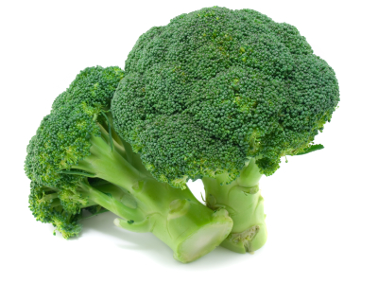
Beneficial Bites
- Broccoli has more nutrients than any other vegetable!
- Need some grown-up reasons for eating your broccoli? How about vitamins C and K, potassium, calcium, antioxidants, and phytochemicals. And there’s plenty more where that came from!
- Just a half cup of raw or cooked broccoli counts as a serving of vegetables (roughly the size of a light bulb) for just 15 calories.
Did you Know?
- Broccoli has been around for nearly 2000 years, but has only been grown in the United States for 200 years.
- It originated along the Mediterranean Coast; maybe that’s why the most common variety is the Italian Green!
- California is broccoli country—over 90% of the nation’s broccoli is grown there.
- Broccoli heads are actually groups of tiny buds that are almost ready to flower—hence the term florets!
- There are many varieties of broccoli, some with different colors: yellow-green, white, and even purple.
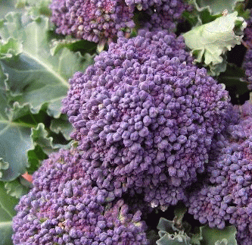
Food for Thought
- Want the nutrition benefit of broccoli but not fond of the taste? Try broccolini, a milder, sweeter version, also called baby broccoli.
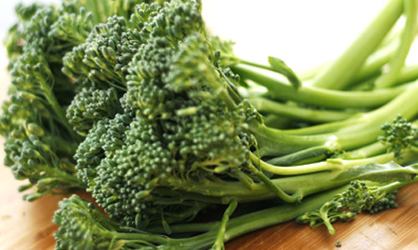
- Broccoli will have the best taste and nutritional value if eaten within 3-5 days.
- Deeper color = more nutrients!
- Get creative with your broccoli. Roast with olive oil and spices, herbs, or nuts.
  - Toss broccoli with olive oil, sliced garlic, salt, and pepper
  - Spread on a baking sheet
  - Bake at 450° for 20 minutes

Created by Amy Erickson, University of Wisconsin-Stout Dietetic Intern 2012

