Beneficial Bites
- Love it or hate it, this powerful vegetable packs the most nutrients of any other: vitamins A, B6, and C, and calcium, iron, and potassium, to name a few.
- Broccoli is also rich in vitamin K, which helps to clot the blood. Those taking blood thinners need to eat vitamin K foods like broccoli in steady amounts.
Interesting Facts
- Fresh broccoli will taste best and have the highest nutrient content if consumed within 3-5 days.
- Broccoli isn’t just green; there are purple and yellow-green varieties as well.
- Calabrese, the most common type found in the U.S., is named for the region of Italy where it was first grown.
- Broccolini has a milder flavor, while broccoli rabe is stronger.
Created by Amy Erickson, University of Wisconsin-Stout Dietetic Intern 2012

Beneficial Bites
- Love it or hate it, this powerful vegetable packs the most nutrients of any other: vitamins A, B6, and C, and calcium, iron, and potassium, to name a few.
- Broccoli is also rich in vitamin K, which helps to clot the blood. Those taking blood thinners need to eat vitamin K foods like broccoli in steady amounts.
Interesting Facts
- Fresh broccoli will taste best and have the highest nutrient content if consumed within 3-5 days.
- Broccoli isn’t just green; there are purple and yellow-green varieties as well.
- Calabrese, the most common type found in the U.S., is named for the region of Italy where it was first grown.
- Broccolini has a milder flavor, while broccoli rabe is stronger.
Created by Amy Erickson, University of Wisconsin-Stout Dietetic Intern 2012

Beneficial Bites
- Love it or hate it, this powerful vegetable packs the most nutrients of any other: vitamins A, B6, and C, and calcium, iron, and potassium, to name a few.
- Broccoli is also rich in vitamin K, which helps to clot the blood. Those taking blood thinners need to eat vitamin K foods like broccoli in steady amounts.
Interesting Facts
- Fresh broccoli will taste best and have the highest nutrient content if consumed within 3-5 days.
- Broccoli isn’t just green; there are purple and yellow-green varieties as well.
- Calabrese, the most common type found in the U.S., is named for the region of Italy where it was first grown.
- Broccolini has a milder flavor, while broccoli rabe is stronger.
Created by Amy Erickson, University of Wisconsin-Stout Dietetic Intern 2012
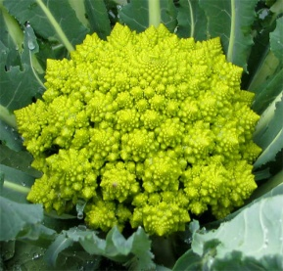
Rediscover broccoli!
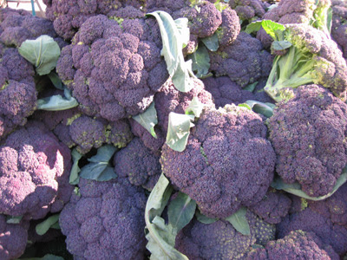
Fill in the blanks: find broccoli-related words in this flyer to spell out broccoli.
V _ T _ _ _ _ B _
_ A _ _ B R _ _ _
_ L _ O _ T _ _ _ _ _ _ _
_ R _ _ C _ _ _ R _ _ _
B _ _ C _ _ _ _ _ N _
_ O _ A _ _ I _ _
C _ L _ _ _ _
I _ _ N
Rediscover broccoli!
Fill in the blanks: find broccoli-related words in this flyer to spell out broccoli.
V _ T _ _ _ _ B _
_ A _ _ B R _ _ _
_ L _ O _ T _ _ _ _ _ _ _
_ R _ _ C _ _ _ R _ _ _
B _ _ C _ _ _ _ _ N _
_ O _ A _ _ I _ _
C _ L _ _ _ _
I _ _ N
Rediscover broccoli!
Fill in the blanks: find broccoli-related words in this flyer to spell out broccoli.
V _ T _ _ _ _ B _
_ A _ _ B R _ _ _
_ L _ O _ T _ _ _ _ _ _ _
_ R _ _ C _ _ _ R _ _ _
B _ _ C _ _ _ _ _ N _
_ O _ A _ _ I _ _
C _ L _ _ _ _
I _ _ N

