

Beneficial Bites

Bok Choy

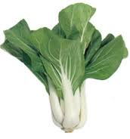

**Health Benefits:**

* Low in calories—only 13 calories in 1 cup!
* Being researched for its cancer-fighting properties
* The high vitamin C boosts immune system
* Fiber content aids in digestion

Interesting Facts:

* Bok choy is referred to as a variety of names including “white cabbage”, “Chinese cabbage”, “pak choi”, and “the soup spoon”.
* Although bok choy was introduced to the US over 100 years ago, it is still strongly associated with Asian cooking.
* Bok choy looks like celery, but is actually a distant relative of broccoli, kale, cauliflower, and Brussels sprouts.



Beneficial Bites

Bok Choy



**Health Benefits:**

* Low in calories—only 13 calories in 1 cup!
* Being researched for its cancer-fighting properties
* The high vitamin C boosts immune system
* Fiber content aids in digestion

Interesting Facts:

* Bok choy is referred to as a variety of names including “white cabbage”, “Chinese cabbage”, “pak choi”, and “the soup spoon”.
* Although bok choy was introduced to the US over 100 years ago, it is still strongly associated with Asian cooking.
* Bok choy looks like celery, but is actually a distant relative of broccoli, kale, cauliflower, and Brussels sprouts.



Beneficial Bites

Bok Choy



**Health Benefits:**

* Low in calories—only 13 calories in 1 cup!
* Being researched for its cancer-fighting properties
* The high vitamin C boosts immune system
* Fiber content aids in digestion

Interesting Facts:

* Bok choy is referred to as a variety of names including “white cabbage”, “Chinese cabbage”, “pak choi”, and “the soup spoon”.
* Although bok choy was introduced to the US over 100 years ago, it is still strongly associated with Asian cooking.
* Bok choy looks like celery, but is actually a distant relative of broccoli, kale, cauliflower, and Brussels sprouts.

Check out the July menu for these “Bok Choy” foods

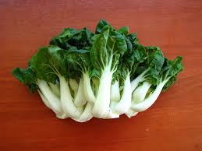

Featured Recipes:

* **Tossed Asian Side Salad with Bok Choy**
* **Mock Chow Mein Casserole with Bok Choy**
* **Crunchy Bok Choy Slaw**
* **Baby Bok Choy & Beef Noodle Soup**
* **Roasted Baby Bok Choy**
* Broccoli cream soup with green onion
* Scallion couscous
* Potato salad with sour cream and green onion
* Salmon with scallion relish
* Beef and scallion stir fry

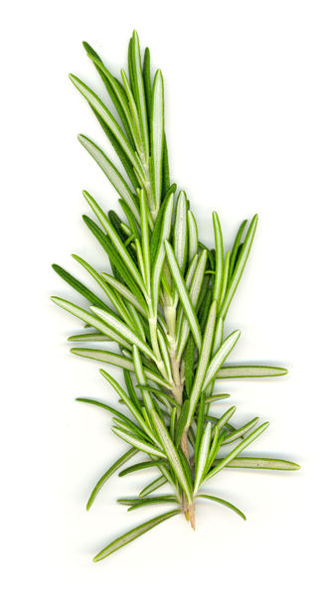

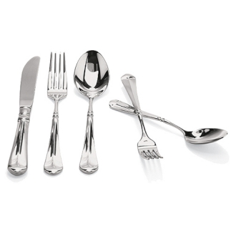

Created by Kathryn Hoff, MS

UW-Stout Dietetic Intern, April 2015

Check out the July menu for these “Bok Choy” foods



Featured Recipes:

* **Tossed Asian Side Salad with Bok Choy**
* **Mock Chow Mein Casserole with Bok Choy**
* **Crunchy Bok Choy Slaw**
* **Baby Bok Choy & Beef Noodle Soup**
* **Roasted Baby Bok Choy**
* Broccoli cream soup with green onion
* Scallion couscous
* Potato salad with sour cream and green onion
* Salmon with scallion relish
* Beef and scallion stir fry



Created by Kathryn Hoff, MS

UW-Stout Dietetic Intern, April 2015

Check out the July menu for these “Bok Choy” foods



Featured Recipes:

* Broccoli cream soup with green onion
* **Tossed Asian Side Salad with Bok Choy**
* **Mock Chow Mein Casserole with Bok Choy**
* **Crunchy Bok Choy Slaw**
* **Baby Bok Choy & Beef Noodle Soup**
* **Roasted Baby Bok Choy**
* Scallion couscous
* Potato salad with sour cream and green onion
* Salmon with scallion relish
* Beef and scallion stir fry



Created by Kathryn Hoff, MS

UW-Stout Dietetic Intern, April 2015