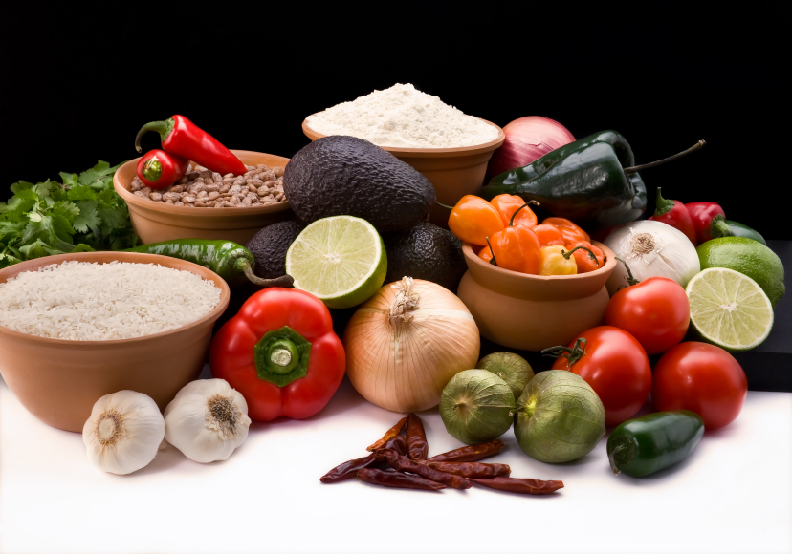
Recipe for: Blueberry Power Smoothie

2 packages (6 oz each) blueberries, fresh1 T chia seeds
½ cup packed baby spinach1 T honey
1 frozen banana1 cup ice
½ ripe avocado¼ cup Greek yogurt
½ cup water½ tsp ground flax seed

Blend all ingredients together in blender until smooth, stirring as necessary. Serve immediately.

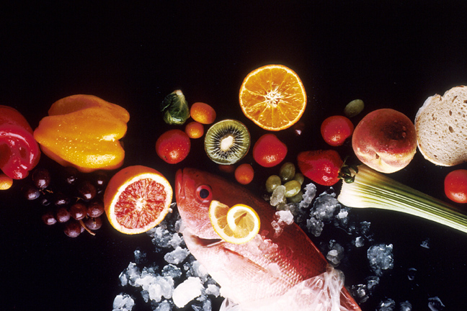
Recipe for: Dark Chocolate Blueberry Bark

1 ¼ cup blueberries, fresh
16 oz dark chocolate chips, chopped
3 oz slivered almonds, toasted and cooled

Line a rimmed baking sheet with parchment paper. Melt chocolate in microwave or double boiler until smooth. Spread chocolate on parchment, sprinkle with blueberries and almonds. Gently press toppings into melted chocolate. Cover loosely with plastic wrap and refrigerate one hour. Use sharp knife to cut into squares.

Recipe for: Blueberry Salsa
2 cups blueberries, fresh, coarsely chopped
1 cup whole blueberries, fresh
¼ cup lemon juice
3 T cilantro, fresh, chopped
2 jalapenos, seeded and minced
1/3 cup red bell pepper, diced
½ tsp kosher salt

Toss all ingredients together in large bowl. Serve immediately with tortilla chips or cover and chill for 8 hours.

Recipe for: Mexican Salad with Blueberries
1 ½ cup corn kernels1 avocado, diced
2 tsp olive oil½ cup cilantro leaves, chopped
4 cups romaine lettuce, shredded2 T lime juice
1 package (6 oz) blueberries, fresh½ tsp salt

Preheat oven to 400⁰ F. Toss olive oil and corn in bowl, spread on baking sheet lined with parchment paper and roast about 25 minutes. Stir with wooden spoon and roast an additional 5-10 minutes. Let cool slightly.
While corn is roasting, toss romaine, blueberries, avocado, cilantro, lime juice, and salt in bowl until evenly coated. Add corn and toss. Serve immediately.

